**PRACTICAL 1**

**SIMPLE XML FILE FOR ADDRESS BOOK**

**Aim: C**reating a simple XML document.

# Algorithm:

Step 1: Open notepad.

Step 2: Define root element as addbook. Step 3: Define Element as details.

Step 4: Define sub element like name,DOB,city,state,pincode,work. Step 5: Define attribute for the work as title and company.

Step 6: Close all the tag of subsequent element. Step 7: Save the file with .xml extension.

Step 8: Open Browser and open the XML file.



# XML CODE:

<?xml version="1.0"?>

<addbook>

<details>

<name>John Smith</name>

<DOB>2-january-1978</DOB>

<city>Chennai</city>

<state>Tamilnadu</state>

<pincode>600089</pincode>

<work title="Project Manager" company="TCS" city="Chennai"></work>

<phoneno>984002561</phoneno>

<email[>j](mailto:john@yahoo.in)o[hn@yahoo.in](mailto:john@yahoo.in)</email>

</details>

<details>

<name>Annie</name>

<DOB>30-March-1982</DOB>

<city>Ville Parle</city>

<state>Mumbai</state>

<pincode>876001</pincode>

<work title="HR" company="Wipro" city="Mumbai"></work>

<phoneno>9600560190</phoneno>

<email[>an](mailto:annie@gmail.com)n[ie@gmail.com](mailto:annie@gmail.com)</email>

</details>

</addbook>

# OUTPUT:

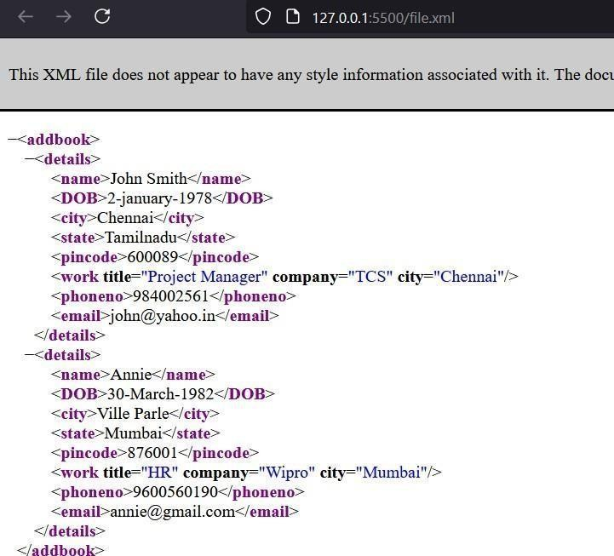

**PRACTICAL 2**

# SIMPLE XML DOCUMENT-ATTRIBUTES

**Aim: Cr**eating a simple XML document with attributes.

# Algorithm:

Step 1: Open notepad.

Step 2: Define root element as ADDRESSBOOK Step 3: Define Sub Element.

Step 4: Define sub attributes like name, DOB, city, state, pincode, email, phone. Step 5: Close all the tags.

Step 6: Save the file with .xml extension.

Step 7: Open Browser and open the XML file.

**XML CODE:**

<ADDRESSBOOK>

<PERSON1

Name="N Krishnamoorthy" Age="45"

Dob="06-02-1976" Mobile="944339443"

Mail="[krishnamoorthy@yahoo.com"](mailto:krishnamoorthy@yahoo.com) Streetname="Thiruneermalai Road" Houseno="303" Area="Thirumudivakkam" Pincode="600044"

City="Chennai" State="Tamilnadu"

/>

<PERSON2

Name="Balavinayagam" Age="27"

Dob="09-06-1990" Mobile="9600365435"

Mail="[balavinayak@yahoo.com"](mailto:balavinayak@yahoo.com) Streetname="North Car Street" Houseno="77/99a" Area="Rockfort" Pincode="600002"

City="tiruchirappalli" State="Tamilnadu"

/>

<PERSON3

Name="Sushmitha" Age="47" Dob="09-02-1970"

Mobile="9789548789"

Mail[="S](mailto:Sushmi_67@gmail.com)us[hmi_67@gmail.com](mailto:Sushmi_67@gmail.com)" Streetname="Haneefa Colony" Houseno="548" Area="Vaniyambadi" Pincode="625689" City="Vaniyambadi" State="Tamilnadu"

/>

</ADDRESSBOOK>

# OUTPUT:

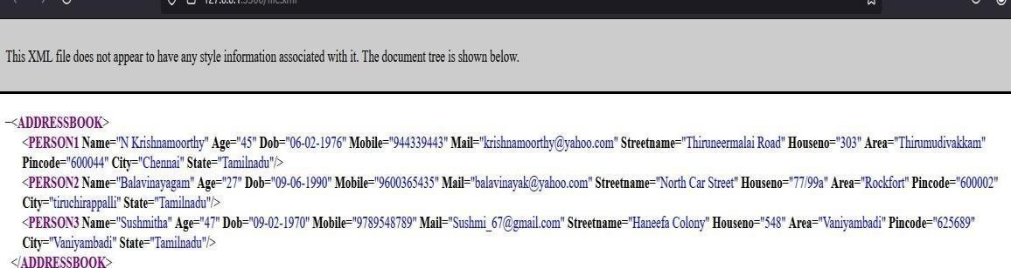

**PRACTICAL 3 INTERNAL DTD IMPLEMENTATION**

**Aim:** Create an XML file using the Internal.

# Algorithm:

**Step 1:** Open <!DOCTYPE declare root element as ‘bookstore’.

**Step 2:** Declare elements name, topic into bookstore.

**Step 3:** Declare elements name, ISBN attribute of book into topic.

**Step 4:** Elements name, title, author as PCDATA.

**Step 5:** Root element consist of Mike’s store as name value, topic consist of xml as name value, ISBN is 120-90-100 attribute of book,title include some contents, Mike Jervis as author value.

# XML CODE:

<?xml version="1.0"?>

<!DOCTYPE bookstore [

<!ELEMENT bookstore (name,topic+)>

<!ELEMENT topic (name,book*)>

<!ELEMENT name (#PCDATA)>

<!ELEMENT book (title,author)>

<!ELEMENT title (#PCDATA)>

<!ELEMENT author (#PCDATA)>

<!ATTLIST book ISBN CDATA "0">

]>

<bookstore>

<name>Mike's Store</name>

<topic>

<name>XML</name>

<book ISBN="120-90-100">

<title>Mike's Guide To DTD's and XML Schemas</title>

<author>Mike Jervis</author>

</book>

</topic>

</bookstore>

# OUTPUT:

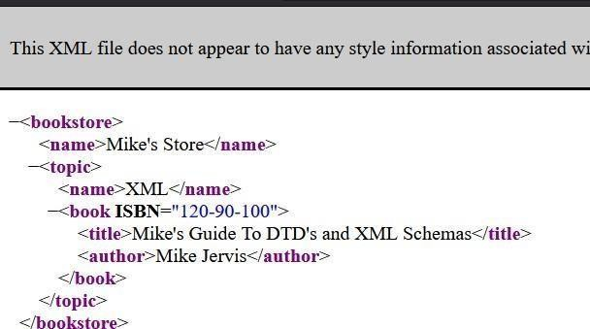

**PRACTICAL 4 XML SCHEMA**

**Aim**: Creating an XML Schema.

# Algorithm:

**Step 1:** Open notepad for creating .dtd file for xml schema definition .

**Step 2:** Define the data types of elements which is to be defined in xml file.

**Step 3:** Close the root element of .dtd file and save it.

**Step 4:** Open another notepad for xml file

**Step 5:** Define respected element as defined in the .dtd file and define the value.

**Step 6:** Close all the subsequent elements tag.

**Step 7:** Save the file with .xml extension

**Step 8:** Open Browser and open the XML file.

# XSD CODE:

<?xml version="1.0" encoding="UTF-8"?>

<xs:schema xmlns:xs="[http://www.w3.org/2001/XMLSchema"](http://www.w3.org/2001/XMLSchema) targetNamespace="[http://www.w3schools.co](http://www.w3schools.co/) m" elementFormDefault="qualified">

<xs:element name="note">

<xs:complexType>

<xs:sequence>

<xs:element name="to" type="xs:string"/>

<xs:element name="from" type="xs:string"/>

<xs:element name="heading" type="xs:string"/>

<xs:element name="body" type="xs:string"/>

</xs:sequence>

</xs:complexType>

</xs:element>

</xs:schema>

# XML file:

<?xml version="1.0" encoding="UTF-8"?>

<note xmlns="[http://www.w3schools.com](http://www.w3schools.com/)" xmlns:xsi=["ht](http://www.w3.org/2001/XMLSchema-instance)t[p://www.w3.org/2001/XMLSchema-instance"](http://www.w3.org/2001/XMLSchema-instance) xsi:schemaLocation=["http:/](http://www.w3schools.com/)/[www.w3schools.com](http://www.w3schools.com/) note.xsd">

<to>Tove</to>

<from>Jani</from>

<heading>Reminder</heading>

<body>Don't forget me this weekend!</body>

</note>

# OUTPUT:

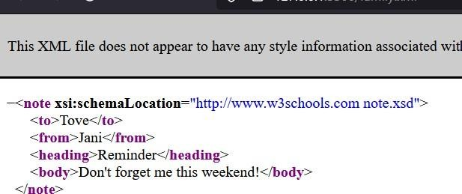

**PRACTICAL 5 CASCADING STYLE SHEET**

**Aim:** Create an xml file to implement .css concept.

# Algorithm:

**Step 1:** Open notepad.

**Step 2**: Write css code for the elements and sub elements and save it with .css extension.

**Step 3:** Create a new XML file and implement the css file in XML file.

Save it with .css extension.

**Step 4:** Open Browser and open the XML file.

# CSS CODE:

bookstore {

border: 10px solid black; width: 90%;

margin: 50px; position: relative;

font-family: Algerian, sans-serif;

}

book {

text-align: center; font-weight: bold;

}

h1 {

background-color: pink; font-size: 200%; padding: 5px;

color: blue; margin: 10px 0; display: block;

}

title {

background-color: pink; font-size: 150%;

color: green; padding: 5px;

margin-top: 20px; display: block;

}

author {

background-color: pink; font-size: 250%; padding: 5px;

color: #800000;

text-decoration: underline; margin-top: 20px; display: block;

text-align: center;

}

price {

font-size: 150%; padding: 5px; color: orange;

background-color: pink; display:block;

margin-top: 20px;

}

# XML CODE:

<?xml version="1.0"?>

<?xml-stylesheet type="text/css" href="bookes.css"?>

<bookstore>

<book>

<h1>BOOK DETAIL</h1>

<title>TITLE: ANSI C</title>

<author>AUTHOR : BALAGURUSAMY</author>

<price>PRICE : 250</price>

</book>

</bookstore>

# OUTPUT:

**PRACTICAL 6**

# XSL TRANSFORMATION

**Aim:** To create a simple XSLT transformation from XSL to XML.

# Algorithm:

**Step 1:** Create a XSLT document using notepad.

**Step 2:** Using XSLT document, we can create a style sheet like Font Style, Font Size, bgcolor,..etc. and write the following code: :“cdcatalog.xsl”

**Step 3:** Save the document as“ Filename.xsl”.

**Step 4:** Then create a XML document.

**Step 5:** Create a Link with the XSLT document using href tag=”Filename.xsl” and write the following code: “Simpxsl.xml”

**Step 6:** Save the document as “Simpxsl.xml”.

**Step 7:** Then execute the xml file and view the output.

# XSL CODE:

<?xml version="1.0" encoding="UTF-8" ?>

<xsl:stylesheet version="1.0" xmlns:xsl=["ht](http://www.w3.org/1999/XSL/Transform)t[p://www.w3.org/1999/XSL/Transform">](http://www.w3.org/1999/XSL/Transform)

<xsl:template match="/">

<html>

<body>

<h2>My CD Collection</h2>

<table border="1">

<trbgcolor="#9acd32">

<th style="text-align:left">Title</th>

<th style="text-align:left">Artist</th>

</tr>

<xsl:for-each select="catalog/cd">

<tr>

<td><xsl:value-of select="title"/></td>

<td><xsl:value-of select="artist"/></td>

</tr>

</xsl:for-each>

</table>

</body>

</html>

</xsl:template>

</xsl:stylesheet>

# XML CODE:

<?xml version="1.0" encoding="UTF-8" ?>

<?xml-stylesheet type="text/xsl" href="cdcatalog.xsl"?>

<catalog>

<cd>

<title>Empire Burlesque</title>

<artist>Bob Dylan</artist>

<country>USA</country>

<company>Columbia</company>

<price>10.90</price>

<year>1985</year>

</cd>

<cd>

<title>Hide your heart</title>

<artist>Bonnie Tyler</artist>

<country>UK</country>

<company>CBS Records</company>

<price>9.90</price>

<year>1988</year>

</cd>

<cd>

<title>Greatest Hits</title>

<artist>Dolly Parton</artist>

<country>USA</country>

<company>RCA</company>

<price>9.90</price>

<year>1982</year>

</cd>

<cd>

<title>Still got the blues</title>

<artist>Gary Moore</artist>

<country>UK</country>

<company>Virgin records</company>

<price>10.20</price>

<year>1990</year>

</cd>

<cd>

<title>Eros</title>

<artist>Eros Ramazzotti</artist>

<country>EU</country>

<company>BMG</company><price>9.90</price>

<year>1997</year>

</cd>

<cd>

<title>One night only</title>

<artist>Bee Gees</artist>

<country>UK</country>

<company>Polydor</company>

<price>10.90</price>

<year>1998</year>

</cd>

<cd>

<title>Sylvias Mother</title>

<artist>Dr.Hook</artist>

<country>UK</country>

<company>CBS</company>

<price>8.10</price>

<year>1973</year>

</cd>

<cd>

<title>Maggie May</title>

<artist>Rod Stewart</artist>

<country>UK</country>

<company>Pickwick</company>

<price>8.50</price>

<year>1990</year>

</cd>

<cd>

<title>Romanza</title>

<artist>Andrea Bocelli</artist>

<country>EU</country>

<company>Polydor</company>

<price>10.80</price>

<year>1996</year>

</cd>

<cd>

<title>When a man loves a woman</title>

<artist>Percy Sledge</artist>

<country>USA</country>

<company>Atlantic</company>

<price>8.70</price>

<year>1987</year>

</cd>

<cd>

<title>Black angel</title>

<artist>Savage Rose</artist>

<country>EU</country>

<company>Mega</company>

<price>10.90</price>

<year>1995</year>

</cd>

<cd>

<title>1999 Grammy Nominees</title>

<artist>Many</artist>

<country>USA</country>

<company>Grammy</company>

<price>10.20</price>

<year>1999</year>

</cd>

<cd>

<title>For the good times</title>

<artist>Kenny Rogers</artist>

<country>UK</country>

<company>Mucik Master</company>

<price>8.70</price>

<year>1995</year>

</cd>

<cd>

<title>Big Willie style</title>

<artist>Will Smith</artist>

<country>USA</country>

<company>Columbia</company>

<price>9.90</price>

<year>1997</year>

</cd>

<cd>

<title>Tupelo Honey</title>

<artist>Van Morrison</artist>

<country>UK</country>

<company>Polydor</company>

<price>8.20</price>

<year>1971</year>

</cd>

<cd>

<title>Soulsville</title>

<artist>JornHoel</artist>

<country>Norway</country>

<company>WEA</company>

<price>7.90</price>

<year>1996</year>

</cd>

<cd>

<title>The very best of</title>

<artist>Cat Stevens</artist>

<country>UK</country>

<company>Island</company>

<price>8.90</price>

<year>1990</year>

</cd>

<cd>

<title>Stop</title>

<artist>Sam Brown</artist>

<country>UK</country>

<company>A and M</company>

<price>8.90</price>

<year>1988</year>

</cd>

<cd>

<title>Bridge of Spies</title>

<artist>T`Pau</artist>

<country>UK</country>

<company>Siren</company>

<price>7.90</price>

<year>1987</year>

</cd>

<cd>

<title>Private Dancer</title>

<artist>Tina Turner</artist>

<country>UK</country>

<company>Capitol</company>

<price>8.90</price>

<year>1983</year>

</cd>

<cd>

<title>Midtomnatten</title>

<artist>Kim Larsen</artist>

<country>EU</country>

<company>Medley</company>

<price>7.80</price>

<year>1983</year>

</cd>

<cd>

<title>Pavarotti Gala Concert</title>

<artist>Luciano Pavarotti</artist>

<country>UK</country>

<company>DECCA</company>

<price>9.90</price>

<year>1991</year>

</cd>

<cd>

<title>The dock of the bay</title>

<artist>Otis Redding</artist>

<country>USA</country>

<company>Atlantic</company>

<price>7.90</price>

<year>1987</year>

</cd>

<cd>

<title>Picture book</title>

<artist>Simply Red</artist>

<country>EU</country>

<company>Elektra</company>

<price>7.20</price>

<year>1985</year>

</cd>

<cd>

<title>Red</title>

<artist>The Communards</artist>

<country>UK</country>

<company>London</company>

<price>7.80</price>

<year>1987</year>

</cd>

<cd>

<title>Unchain my heart</title>

<artist>Joe Cocker</artist>

<country>USA</country>

<company>EMI</company>

<price>8.20</price>

<year>1987</year>

</cd>

</catalog>

# OUTPUT:

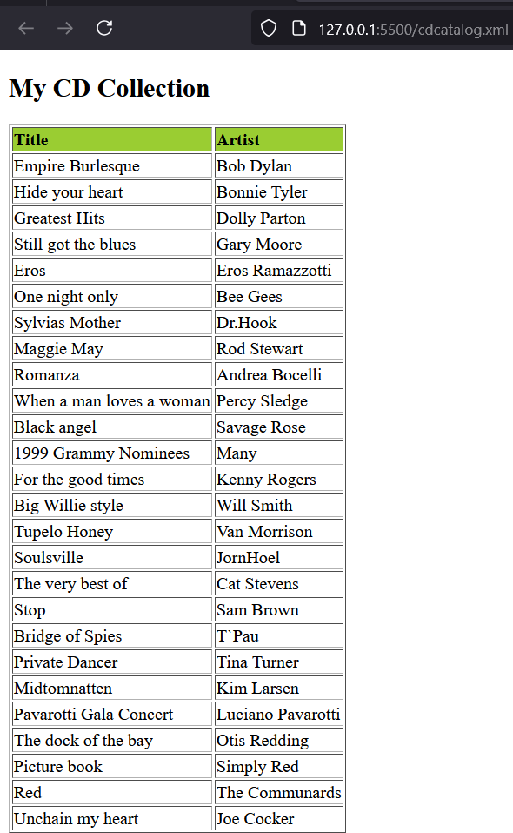

**PRACTICAL 7**

# XSL TRANSFORMATION- BOOK SHOP

**Aim:** To create a simple XSLT transformation from XSL to XML.

# Algorithm:

**Step 1:** Create a XSLT document using notepad.

**Step 2:** Using XSLT document, we can create a style sheet like Font Style, Font Size, bgcolor,..etc. and write the following code:

**Step 3:** Save the document as :“style.xsl”. Step-4: Then create a XML document.

**Step 4:** Create a Link with the XSLT document using href tag=”style.xsl” and write the following code:

**Step 5:** Save the document as “Book.xml”.

**Step 6:** Then execute the xml file and view the output.



# XML CODE:

<?xml version="1.0"?>

<?xml-stylesheet type="text/xsl" href="style.xsl"?>

<BooksforYou>

<Book BookID = "1000">

<Title>If Tomorrow Comes</Title>

<Rate>275</Rate>

<Author>Krishna Kumar</Author>

<Publication>Pearson</Publication>

<ISBN>111-222-333</ISBN>

</Book>

<Book BookID ="1001">

<Title>.NET Expert Guide</Title>

<Rate>475</Rate>

<Author>James</Author>

<Publication>Microsoft Press</Publication>

<ISBN>121-222-333</ISBN>

</Book>

<Book BookID ="1002">

<Title>C Projects</Title>

<Rate>275</Rate>

<Author>YashwantP.Kanetkar</Author>

<Publication>BPB Publications</Publication>

<ISBN>111-232-333</ISBN>

</Book>

<Book BookID ="1003">

<Title>Let us C</Title>

<Rate>225</Rate>

<Author>YashwantP.Kanetkar</Author>

<Publication>BPB Publications</Publication>

<ISBN>111-222-353</ISBN>

</Book>

<Book BookID =”1004”>

<Title>Com and Beyond in VC++</Title>

<Rate>375</Rate>

<Author>YashvantP.Kanetkar</Author>

<Publication>BPB Publications</Publication>

<ISBN>111-555-333</ISBN>

</Book>

</BooksforYou>

# XSL CODE:

<?xml version="1.0" encoding="UTF-8"?>

<xsl:stylesheetxmlns:xsl="[http://www.w3.org/1999/XSL/Transform"](http://www.w3.org/1999/XSL/Transform) version="1.0" >

<xsl:template match="/">

<html>

<body background="tech.gif">

<h1 align="center">

<font color="blue">Books at your own Cyber Shoppe</font>

</h1>

<table border="4" cellpadding="10" cellspacing="5" align="center" bgcolor="lightgreen" bordercolor="green">

<tbody>

<tr>

<th>Book ID</th>

<th>Title</th>

<th>Rate</th>

<th>Author</th>

<th>Publication</th>

<th>ISBN</th>

</tr>

<xsl:for-each select="BooksforYou/Book">

<tr>

<td><xsl:value-of select="@BookID"/></td>

<td><xsl:value-of select="Title"/></td>

<td><xsl:value-of select="Rate"/></td>

<td><xsl:value-of select="Author"/></td>

<td><xsl:value-of select="Publication"/></td>

<td><xsl:value-of select="ISBN"/></td>

</tr>

</xsl:for-each>

</tbody>

</table>

</body>

</html>

</xsl:template>

</xsl:stylesheet>

# OUTPUT:

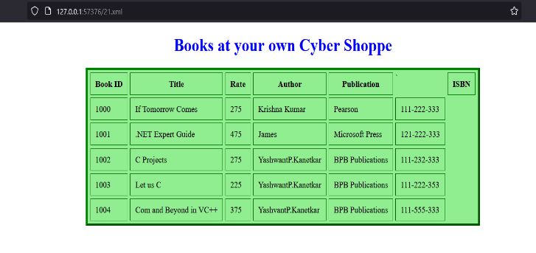

**PRACTICAL 8 XSL FORMATTING**

**Aim:** To demonstrate XSL formatting-how to format numbers using the

<xsl:decimal-format> element.

# Algorithm:

**Step 1:** Create a XML document using notepad.

**Step 2:** In the XML Document specify the .xsl file name in href.

**Step 3:** Save the document as“ Root.xml”.

**Step 4:** Then create a XSLT document.

**Step 5:** Create a Link with the XSLT document using href tag write the code:

**Step 6:** Save the document as “DecimalformaT.xsl”.

**Step 7:** Then execute the xml file and view the output.

# XML CODE:

<?xml version="1.0"?>

<?xml-stylesheet type="text/xsl" href="decimalformat.xsl" ?>

<root/>

# XSL CODE:

<?xml version="1.0"?>

<?xml-stylesheet type="text/xsl" href="decimalformat.xsl"?>

<xsl:stylesheet version="1.0" xmlns:xsl=["ht](http://www.w3.org/1999/XSL/Transform)t[p://www.w3.org/1999/XSL/Transform">](http://www.w3.org/1999/XSL/Transform)

<xsl:output method="html" indent="yes"/>

<xsl:decimal-format name="us" decimal-separator="." grouping-separator=","/>

<xsl:decimal-format name="european" decimal-separator="," grouping- separator="." />

<xsl:decimal-format name="example" decimal-separator="." grouping- separator=","

infinity="INFINITY" minus-sign="-" NaN="Not a Number" percent="%" per- mille="m"

zero-digit="0" digit="#" pattern-separator=";" />

<xsl:template match="/">

<html>

<body>

<table border="1" cellpadding="2" cellspacing="0">

<tr align="center">

<td><b>Data</b></td>

<td><b>Default</b></td>

<td><b>European</b></td>

<td><b>US</b></td>

<td><b>Example</b></td>

</tr>

<tr align="right">

<td>24535.2</td>

<td><xsl:value-of select="format-number(24535.2, '###,###.00')"/></td>

<td><xsl:value-of select="format-number(24535.2, '###.###,00', 'european')"/></td>

<td><xsl:value-of select="format-number(24535.2, '###,###.00', 'us')"/></td>

<td><xsl:value-of select="format-number(24535.2, '###,###.00', 'example')"/></td>

</tr>

</table>

</body>

</html>

</xsl:template>

</xsl:stylesheet>

# OUTPUT:

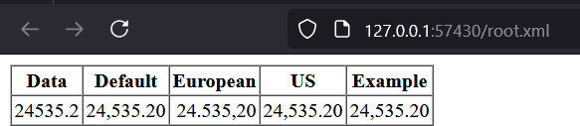

**PRACTICAL 9 XSL FORMATTING**

**Aim:** To demonstrate XSL formatting-how to format using element.

# Algorithm:

**Step 1:** Create an XML document using notepad.

**Step 2:** In the XML Document specify the .xsl file name in href.

**Step 3:** Save the document as “family.xml”.

**Step 4:** Then create a XSLT document.

**Step 5:** Create a Link with the XSLT document using href tag write the code:

**Step 6:** Save the document as “family.xsl”.

**Step 7:** Then execute the xml file and view the output.

# XML CODE:

<?xml version="1.0"?>

<?xml-stylesheet type="text/xsl" href="family.xsl"?>

<family>

<person>

<given-name age="10">

<name>Fred</name>

<nick-name>Freddy</nick-name>

</given-name>

<family-name>Smith</family-name>

</person>

<person>

<given-name age="10">

<name>Robert</name>

<nick-name>Bob</nick-name>

</given-name>

<family-name>Smith</family-name>

</person>

</family>

**XSL CODE:**

<?xml version="1.0"?>

<xsl:stylesheet version="1.0" xmlns:xsl=["ht](http://www.w3.org/1999/XSL/Transform)t[p://www.w3.org/1999/XSL/Transform">](http://www.w3.org/1999/XSL/Transform)

<xsl:template match="/">

<html>

<body>

<xsl:apply-templates select="family/person"/>

</body>

</html>

</xsl:template>

<xsl:template match="person">

<p>

<xsl:value-of select="given-name/name"/>

<xsl:text> </xsl:text>

<xsl:value-of select="given-name/nick-name"/>

<xsl:text> </xsl:text>

<xsl:value-of select="family-name"/>

</p>

</xsl:template>

</xsl:stylesheet>

# OUTPUT:

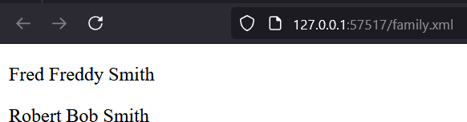

**PRACTICAL 10**

# XSL IMPLEMENTATION

**Aim:** Create an XML file to implement XPATH concept.

# Algorithm:

**Step 1:** Open notepad.

**Step 2:** Write XSL code for the element and sub elements. Save it with .xsl extension.

**Step 3:** Create a new XML file and implement the XSL file in XML file. Save it with .xml extension.

**Step 4:** Open Browser and open the XML file.

# XSL CODE:

<?xml version="1.0" encoding="UTF-8"?>

<xsl:stylesheet version="1.0" xmlns:xsl=["ht](http://www.w3.org/1999/XSL/Transform)t[p://www.w3.org/1999/XSL/Transform">](http://www.w3.org/1999/XSL/Transform)

<xsl:template match="/">

<html>

<body>

<p align="center">

<font color="blue">COMPUTER SHOP</font>

</p>

<xsl:for-each select="purchase/product">

<b>Product id:</b> <xsl:value-of select="@id"/> <br/>

<b>Name:</b> <xsl:value-of select="@name"/> <br/>

<b>Price Per Unit:</b> <xsl:value-of select="@price"/> <br/>

<br/> <br/>

<xsl:for-each select="order">

<b>Order id:</b> <xsl:value-of select="@id"/> <br/>

<b>Quantity:</b> <xsl:value-of select="quantity"/> <br/>

<b>Order Value:</b> <xsl:value-of select="number(../@price) * number(quantity)"/> <br/>

<br/>

</xsl:for-each>

<hr/>

<b>Product Sales Value:</b> <xsl:value-of select="number(@price) *

sum(order/quantity)"/> <br/>

<hr/> <br/>

</xsl:for-each>

</body>

</html>

</xsl:template>

</xsl:stylesheet>

# XML CODE:

<?xml version="1.0"?>

<?xml-stylesheet type="text/xsl" href="xpat.xsl"?>

<purchase>

<product id="P001" name="COMPUTER" price="45000">

<order id="001">

<quantity>30</quantity>

</order>

<order id="002">

<quantity>50</quantity>

</order>

</product>

<product id="P002" name="PRINTER" price="10000">

<order id="003">

<quantity>20</quantity>

</order>

<order id="004">

<quantity>15</quantity>

</order>

</product>

</purchase>

# OUTPUT:

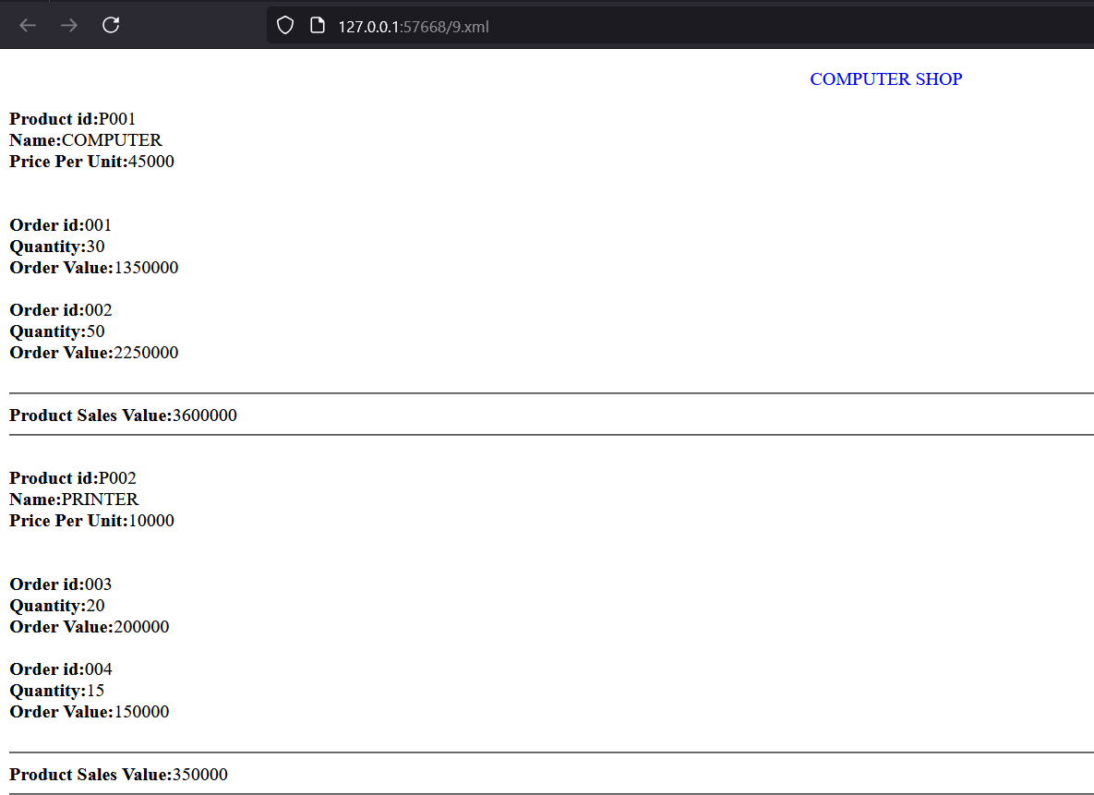

**PRACTICAL 11 XSL DOM CLASS**

**Aim: C**reating an XML DOM class.

# Algorithm:

**Step 1:** Open notepad for creating a simple xml file.

**Step 2:** Define element countries as root. Country and state as subelement.

**Step 3:** Close the root element of .xml file and save it.

**Step 4:** Open another notepad for creating .html file for DOM class. **Step 5:** Declare JavaScript as Script language and print the root and child element of .xml file.

**Step 6:** Close all the subsequent elements tag.

**Step 7:** Save the file with .html extension.

**Step 8:** Open Browser and open the HTML file.

# XML CODE:

<?xml version="1.0"?>

<countries>

<country cname="India">

<state name="TamilNadu">TN</state>

<state name="Keral">KL</state>

<state name="Rajasthan">RJ</state>

<state name="Assam">AS</state>

</country>

<country cname="United States">

<state name="Florida">FL</state>

<state name="Georgia">GA</state>

<state name="Colorado">CO</state>

<state name="Hawaii">HI</state>

</country>

</countries>

# HTML CODE:

<html>

<body>

<SCRIPT LANGUAGE="JavaScript">

var xmlhttp = new XMLHttpRequest(); xmlhttp.open("GET", "country.xml",false); xmlhttp.send();

var xmlDoc = xmlhttp.responseXML;

var countries = xmlDoc.getElementsByTagName("country"); document.write("<h2>Countries and States</h2>");

for (var i = 0; i < countries.length; i++) {

var countryName = countries[i].getAttribute("cname"); document.write("<h3>" + countryName + "</h3>");

var states = countries[i].getElementsByTagName("state"); for(var j = 0; j < states.length; j++) {

var stateName = states[j].getAttribute("name"); var stateCode =states[j].textContent;

document.write("<p>State: " + stateName + " - Code: " + stateCode + "</p>");

}

}

</SCRIPT>

</body>

</html>

# OUTPUT:

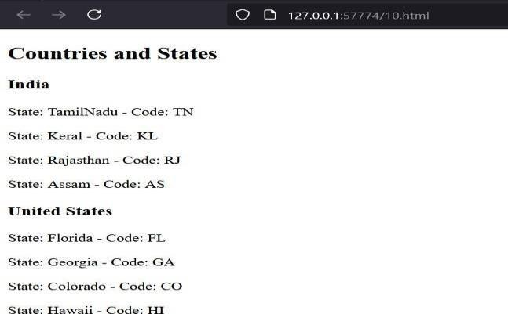

**PRACTICAL 12**

**Simple XML to RDF Aim:** To Convert XML to RDF

**Algorithm:**

Step 1: Open notepad.

Step 2: Define root element

Step 3: Define River rdf as Yangtze . Step 4 : Define xmlns:rdf Path

Step 5: Define properties like Length, Starting location and End Location.

Step 6: Close all the tags of subsequent elements

Step 7: Save the file with the .rdf extension. Step 8: Open Browser and open the RDF file.



# XML File:

<?xml version="1.0"?>

<River id="Yangtze"

xmlns="[http://www.geodesy.org/river"](http://www.geodesy.org/river)>

<length>6300 kilometers</length>

<startingLocation>western China's Qinghai-Tibet Plateau</startingLocation>

<endingLocation>East China Sea</endingLocation>

</River>

# RDF FILE

<?xml version="1.0"?>

<River **rdf:ID**="Yangtze" **xmlns:rdf="**[**http://www.w3.org/1999/02/22-rdf-syntax-ns#**](http://www.w3.org/1999/02/22-rdf-syntax-ns)**"** xmlns="[http://www.geodesy.org/river**#**](http://www.geodesy.org/river)">

<length>6300 kilometers</length>

<startingLocation>western China's Qinghai-Tibet Plateau</startingLocation>

<endingLocation>East China Sea</endingLocation>

</River>

# OUTPUT:

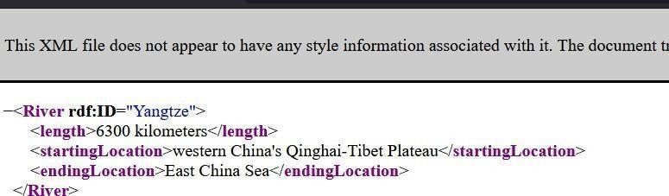

**Practical No.13 Rdf:description** + **RDF:type**

**Algorithm:**

Step 1: Open notepad.

Step 2: Define root element

Step 3: Define River rdf as Yangtze . Step 4 : Define rdf:Description rdf:about.

Step 5: Define properties like Length, Starting location and End Location. Step 6: Close all the tags of subsequent elements

Step 7: Save the file with the .rdf extension. Step 8: Open Browser and open the RDF file.

# RDF CODE:

<?xml version="1.0"?>

# <rdf:Description

rdf:about="[http://www.china.org/geography/rive](http://www.china.org/geography/rivers#Yangtze) [rs#Yan gtze"](http://www.china.org/geography/rivers#Yangtze) xmlns:rdf="[http://www.w3.org/1999/02/22-rdf-](http://www.w3.org/1999/02/22-rdf-syntax-ns) [syntax-ns#](http://www.w3.org/1999/02/22-rdf-syntax-ns)" xmlns="[http://www.geodesy.org/river#](http://www.geodesy.org/river)">

**<rdf:type rdf:resource="**[**http://www.geodesy.org/river#River"/**](http://www.geodesy.org/river#River)**>**

<length>6300 kilometers</length>

<startingLocation>western China's Qinghai-Tibet Plateau</startingLocation>

<endingLocation>East China Sea</endingLocation>

# </rdf:Description>

**OUTPUT:**

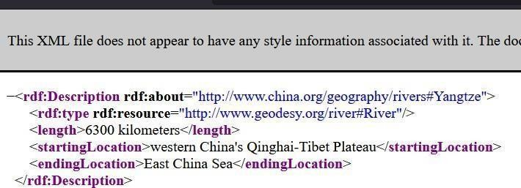

# Practical No.14

**Modify the following XML document so that it is RDF-compliant**

# RDF CODE:

<?xml version="1.0"?>

<River id="Yangtze"

xmlns="[http://www.geodesy.org/river"](http://www.geodesy.org/river)>

<length>6300 kilometers</length>

<startingLocation>western China's Qinghai-Tibet Plateau</startingLocation>

<endingLocation>East China Sea</endingLocation>

**<Dam id="ThreeGorges" xmlns="**[**http://www.geodes**](http://www.geodesy.org/dam)[**y.org/d am**](http://www.geodesy.org/dam)**">**

**<name>The Three Gorges Dam</name>**

# <width>1.5 miles</width>

**<height>610 feet</height>**

# <cost>$30 billion</cost>

**</Dam>**

</River>

# OUTPUT

**PRACTICAL 15**

# rdf:parseType="Resource"

**RDF CODE:**

<?xml version="1.0"?>

<River rdf:ID="Yangtze" xmlns:rdf=["ht](http://www.w3.org/1999/02/22-rdf-syntax-ns)t[p://www.w3.org/1999/02/](http://www.w3.org/1999/02/22-rdf-syntax-ns) [22-rdf- syntax-ns#](http://www.w3.org/1999/02/22-rdf-syntax-ns)" xmlns="[http://www.geodesy.org/river**#**](http://www.geodesy.org/river)"

xmlns:uom="[http://www.measurements.org/units-of-measure#](http://www.measurements.org/units-of-measure)">

# <length rdf:parseType="Resource">

**<rdf:value>6300</rdf:value>**

# <uom:units>kilometers</uom:units>

**</length>**

<startingLocation>western China's Qinghai-Tibet Plateau</startingLocation>

<endingLocation>East China Sea</endingLocation>

</River>

# Output:

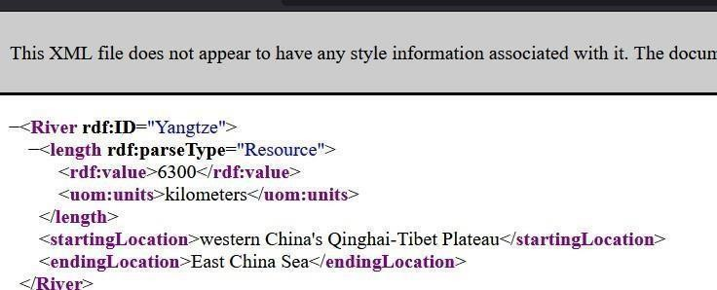

**PRACTICAL 16**

# Modify the following XML document so that it is also a valid RDF document RDF CODE:

<?xml version="1.0"?>

<WeatherReading xmlns=["http](http://www.meteorology.org/):[//www.meteorology.org#](http://www.meteorology.org/)">

<Weather>

<temperature>-2 degrees Celsius</temperature>

<barometer>30.4 (rising)</barometer>

</Weather>

<Location xmlns=["http:/](http://www.geodesy.org/)/[www.geodesy.org#](http://www.geodesy.org/)">

<country>USA</country>

<state>Massachusetts</state>

<city>Boston</city>

</Location>

<datetime>January 22, 2003, 11:15 EST</datetime>

</WeatherReading>

# OUTPUT:

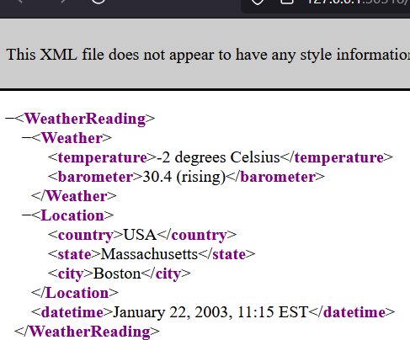

**XML CODE:**

<?xml version="1.0"?>

<River id="Yangtze"

# PRACTICAL 17

**Interpreting the RDF**

xmlns=<http://www.geodesy.org/river> xmlns:uom[="h](http://www.measurements.org/units-of-)tt[p://www.measurements.org/units-of-](http://www.measurements.org/units-of-) measure">

<length uom:units="kilometers">6300</length>

<startingLocation>western China's Qinghai-Tibet Plateau</startingLocation>

<endingLocation>East China Sea</endingLocation>

</River>

# RDF CODE:

<?xml version="1.0"?>

<River id="Yangtze"

xmlns="[http://www.geodesy.org/river"](http://www.geodesy.org/river%22) xmlns:uom="[http://www.measurements.org](http://www.measurements.org/units-of-measure)

[/units-of- measure"](http://www.measurements.org/units-of-measure)>

# <length uom:units="kilometers">6300</length>

<startingLocation>western China's Qinghai-Tibet Plateau</startingLocation>

<endingLocation>East China Sea</endingLocation>

</River>

# OUTPUT:

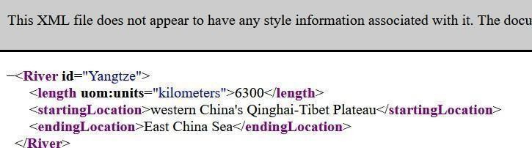

**PRACTICAL 18**

# Modify the following XML document so that it is also a valid RDF document

**XML CODE:**

<?xml version="1.0"?>

<Retailer id="BarnesAndNoble"

xmlns=["http://](http://www.retailers.org/)w[ww.retailers.org](http://www.retailers.org/)">

<webLocation>

<url>[http://www.bn.com<](http://www.bn.com/)/url>

<url>[http://www.barnesandnoble.com</](http://www.barnesandnoble.com/)url>

</webLocation>

</Retailer>

# RDF CODE:

<?xml version="1.0"?>

<Retailer rdf:ID="BarnesAndNoble" xmlns:rdf=["http:/](http://www.w3.org/1999/02/22-rdf-syntax-ns)/[www.w3.org/1999/02/22-rdf-](http://www.w3.org/1999/02/22-rdf-syntax-ns) [syntax-ns#](http://www.w3.org/1999/02/22-rdf-syntax-ns)" xmlns=["http://](http://www.retailers.org/)w[ww.retailers.org#](http://www.retailers.org/)">

<webLocation>

# <rdf:Alt>

**<**url**>**[http://www.bn.com](http://www.bn.com/)**</**url**>**

**<**url> [http://www.barnesandnoble.com](http://www.barnesandnoble.com/)</url>

# </rdf:Alt>

**</webLocation>**

</Retailer>

# OUTPUT:

**PRACTICAL 19**

# Modify the following XML document so that it is also a valid RDF document

**XML CODE:**

<?xml version="1.0"?>

<ToDoList id="MondayMeetings"

xmlns="[http://www.reminders.org">](http://www.reminders.org/)

<activities>

<activity1>Meet with CEO at 10am</activity1>

<activity2>Luncheon at The Eatery</activity2>

<activity3>Flight at 3pm</activity3>

</activities>

</ToDoList>

# RDF CODE:

<?xml version="1.0"?>

<ToDoList rdf:ID="MondayMeetings" xmlns:rdf[="http](http://www.w3.org/1999/02/22-rdf-syntax-ns):/[/www.w3.org/1999/02/22-rdf-](http://www.w3.org/1999/02/22-rdf-syntax-ns) [syntax-ns#](http://www.w3.org/1999/02/22-rdf-syntax-ns)" xmlns="[http://www.reminders.org#](http://www.reminders.org/)">

<activities>

# <rdf:Seq>

**<**activity1**>**Meet with CEO at 10am**</**activity1**>**

**<**activity2**>**Luncheon at The Eatery**</**activity2**>**

**<**activity3**>**Flight at 3pm**</**activity3**>**

# </rdf:Seq>

</activities>

</ToDoList>

# OUTPUT:

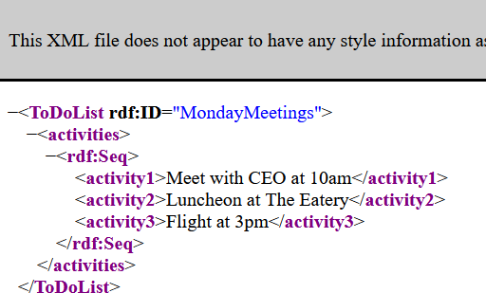

**PRACTICAL 20**

# Modify the following XML document so that it is also a valid RDF document

**XML CODE:**

<?xml version="1.0"?>

<Catalogue id="BookCatalogue" xmlns="[http://www.publishing.org#](http://www.publishing.org/)" xmlns:dc="<http://pur1.org/metadata/dubli>n-core#">

<item>

<Book id="_0-06-099325-2">

<dc:Title>Lateral Thinking</dc:Title>

<dc:Creator>Edward de Bono</dc:Creator>

<dc:Date>1973</dc:Date>

<dc:Publisher>Harper &amp; Row</dc:Publisher>

</Book>

</item>

<item>

<Book id="_0-440-34319-4">

<dc:Title>Illusions: The Adventures of a Reluctant Messiah</dc:Title>

<dc:Creator>Richard Bach</dc:Creator>

<dc:Date>1977</dc:Date>

<dc:Publisher>Dell Publishing Co.</dc:Publisher>

</Book>

</item>

<item>

<Book id="_0-06-064831-7">

<dc:Title>The First and Last Freedom</dc:Title>

<dc:Creator>J. Krishnamurti</dc:Creator>

<dc:Date>1954</dc:Date>

<dc:Publisher>Harper &amp; Row</dc:Publisher>

</Book>

</item>

</Catalogue>

# RDF CODE:

<?xml version="1.0"?>

<Catalogue rdf:ID="BookCatalogue"

xmlns:rdf=["http://www.w3.org/1999/02/22](http://www.w3.org/1999/02/22-rdf-syntax-ns)- [rdf-syntax- ns#"](http://www.w3.org/1999/02/22-rdf-syntax-ns) xmlns=["http://www.publishing.org#](http://www.publishing.org/)" xmlns:dc=["http://pur1.org/metadata/dubli](http://pur1.org/metadata/dublin-core)n[-](http://pur1.org/metadata/dublin-core) [core#"](http://pur1.org/metadata/dublin-core) xml:base=["http://www.bn.com"](http://www.bn.com/)>

<item>

<Book rdf:ID="_0-06-099325-2"

xml:base=["http://www.publishing.org/book"](http://www.publishing.org/book)>

<dc:Title>Lateral Thinking</dc:Title>

<dc:Creator>Edward de Bono</dc:Creator>

<dc:Date>1973</dc:Date>

<dc:Publisher>Harper &amp; Row</dc:Publisher>

</Book>

</item>

<item>

<Book rdf:ID="_0-440-34319-4"

xml:base=["http://www.publishing.org/book"](http://www.publishing.org/book)>

<dc:Title>Illusions: The Adventures of a Reluctant Messiah</dc:Title>

<dc:Creator>Richard Bach</dc:Creator>

<dc:Date>1977</dc:Date>

<dc:Publisher>Dell Publishing Co.</dc:Publisher>

</Book>

</item>

...

</Catalogue>

# OUTPUT:

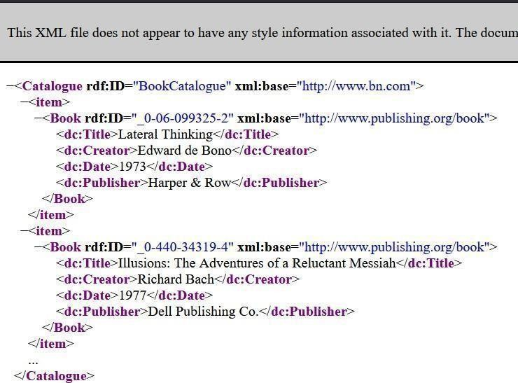

**PRACTICAL 21**

# Modify the following XML document so that it is also a valid RDF document XML CODE:

<?xml version="1.0"?>

<Article id="QuickBrownFox" xmlns="[http://www.publishin](http://www.publishing.org/) [g.org](http://www.publishing.org/)">

<paragraph>

The quick brown <bold>fox</bold> jumped over the lazy dog. An important person once said "<quote>Now is the time for all good men to come to the aid of their country</quote>"

</paragraph>

</Article>

# RDF CODE:

<?xml version="1.0"?>

<Article rdf:ID="QuickBrownFox" xmlns:rdf="[http://www.w3.org/1999/02/22-rdf-](http://www.w3.org/1999/02/22-rdf-syntax-ns) [syntax- ns#](http://www.w3.org/1999/02/22-rdf-syntax-ns)" xmlns="[http://www.publishing.org#](http://www.publishing.org/)">

<paragraph **rdf:parseType="Literal"**>

The quick brown <bold>fox</bold> jumped over the lazy dog. An important person once said "<quote>Now is the time for all good men to come to the aid of their country</quote>"

</paragraph>

</Article>

# OUTPUT:

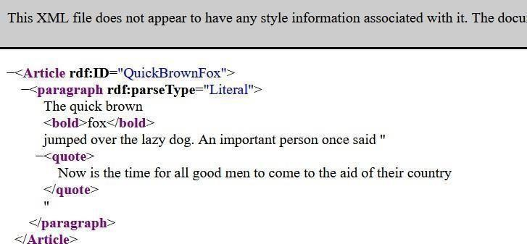

**PRACTICAL 22**

# Create an Ontology for Residential Unit and Person

**STEP 1: Create a Class Hierarchy.**

* Select Entities → Now Click on Classes by adding subclass.

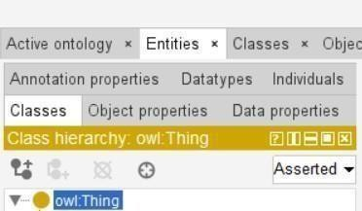

* Select owl:Thing and Click on SubClass to create the new class.



* Add the class as Person and ResidentialUnit in owl:Thing.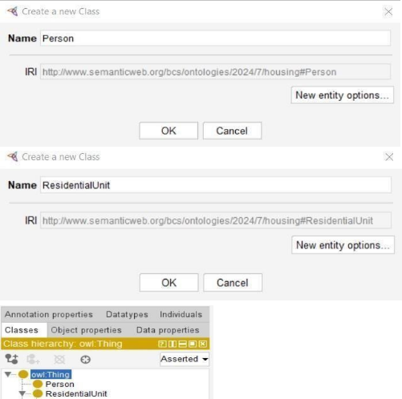
* Add the subclass for ResidentialUnit- Apartment, House.

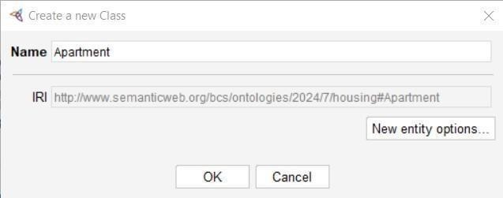

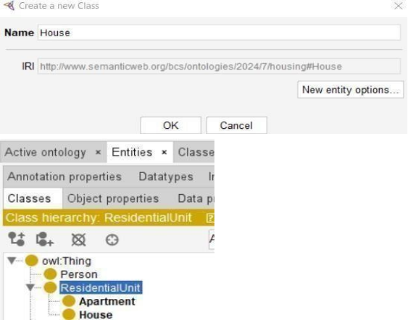

**Step 2: For Individuals by class**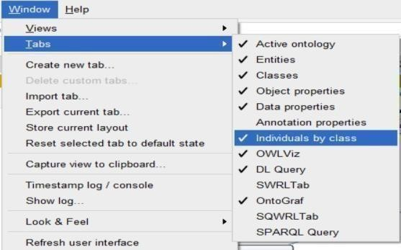

* For Person-

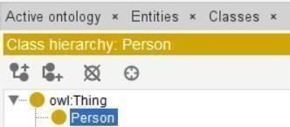

* Click on Person and click on .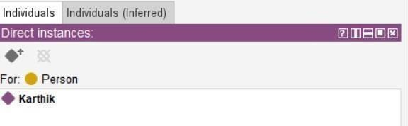
* For Apartment-

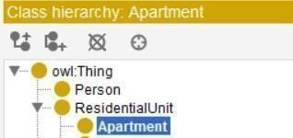

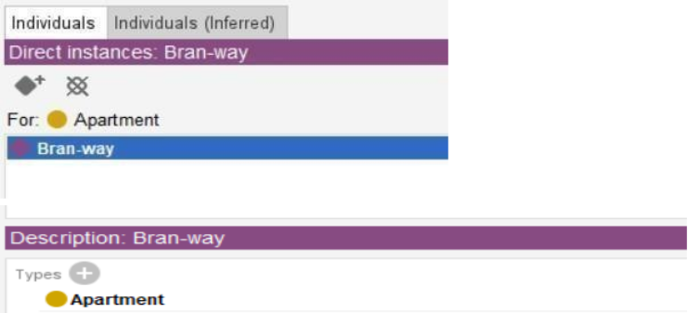

**Step 3: Click on window tab → Select Object Property.**

* Click on Add sub property → Add sub property- Rents, ResidesAt.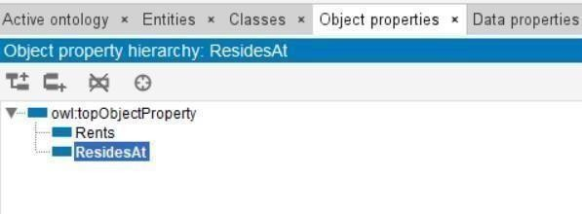

**Step 4: Add sub property Descriptions for ResidesAt.**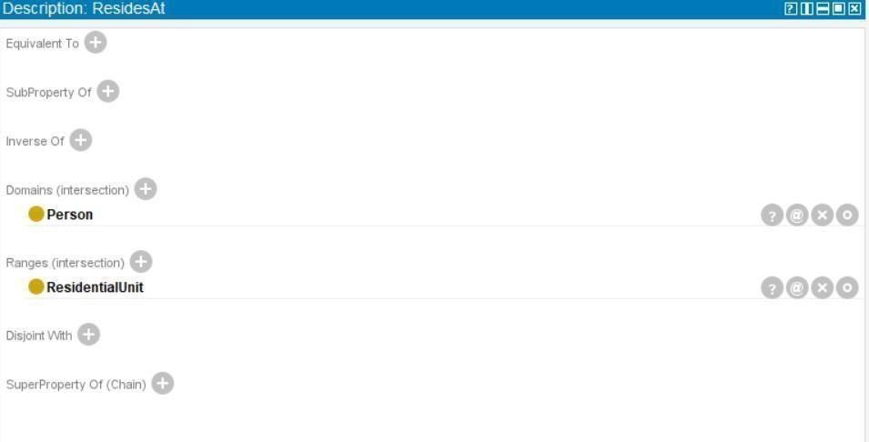

**Step 5:** Add the class as Unit in owl:Thing

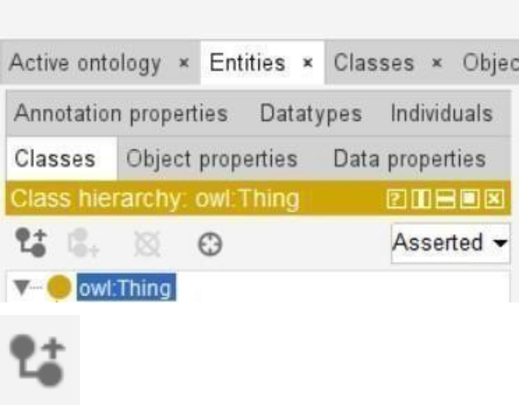

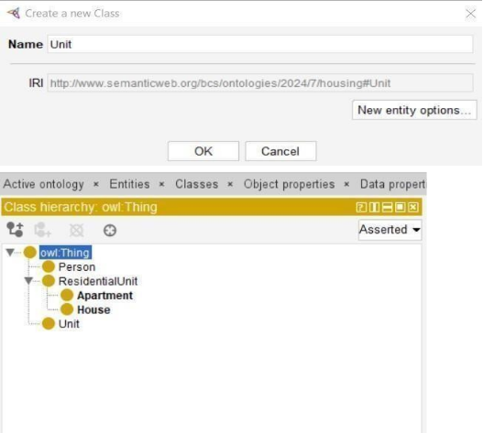

**Step 6:** Data Properties.

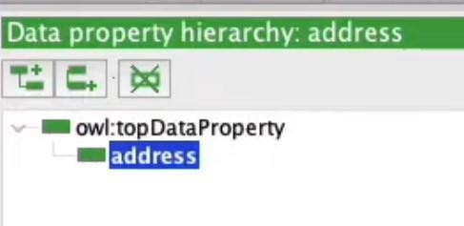

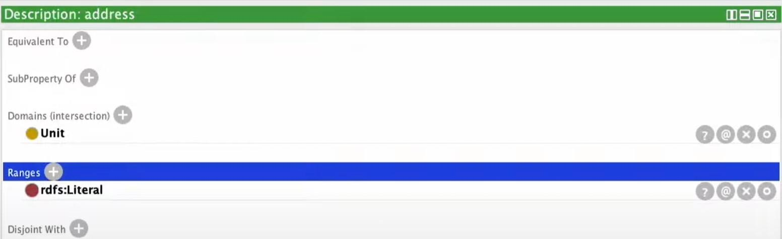

**Output for OWLViz:**

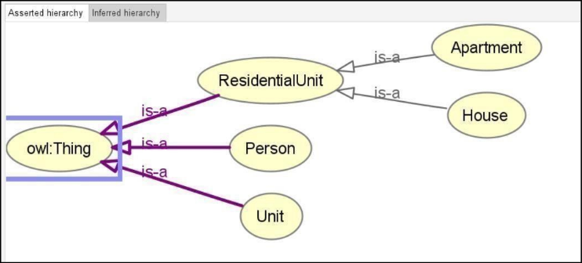

# Practical 23

**Create an Ontology for Education**

**STEP 1: Create a Class Hierarchy.**

Select Entities → Now Click on Classes by adding subclass.

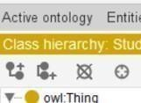

* Select owl:Thing and Click on SubClass to create the new class.
* Add the class as Subject and Student in owl:Thing.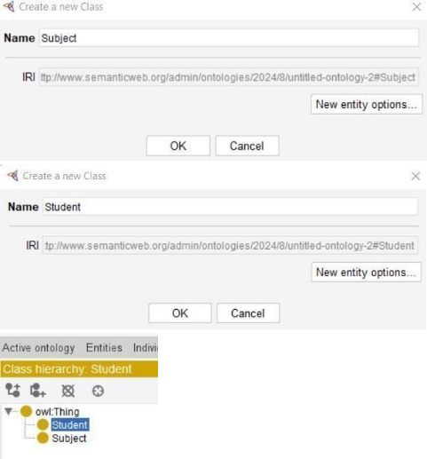
* Add the subclass for Student- Junior_Student, Senior_Student.

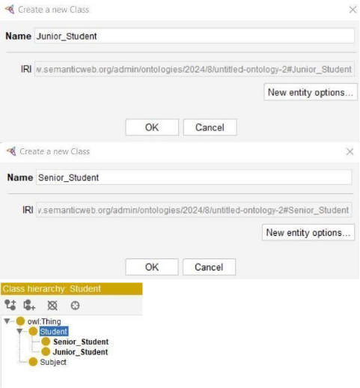

* Add the class as Staff in owl:Thing.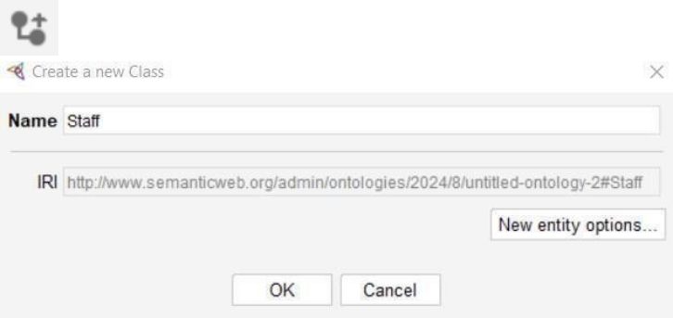
* Add a subclass for Staff- Teaching, Non-Teaching.

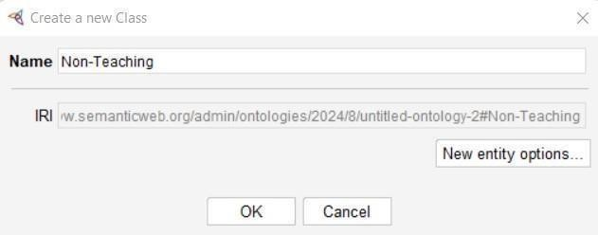

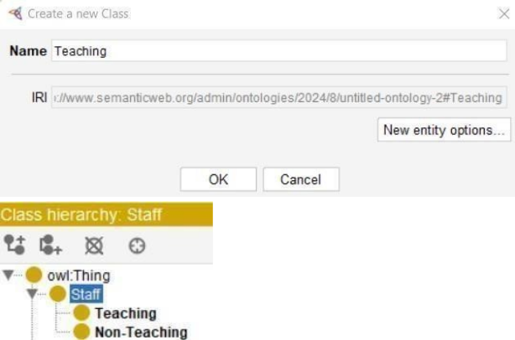

* Add subclass for Non-Teaching- Administrative, House_Keeping, Maintenance, Supporting.

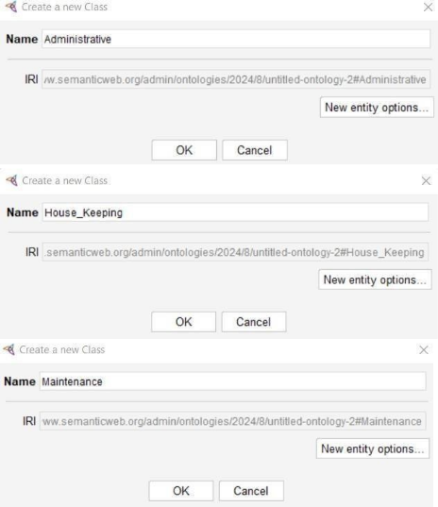

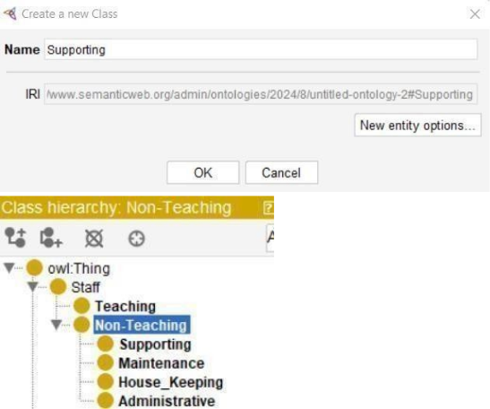

* Add the class as School in owl:Thing.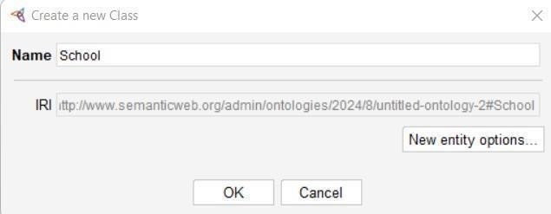
* Add subclass for School- Government, Private.

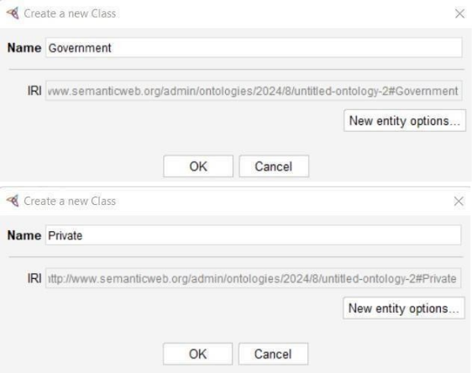

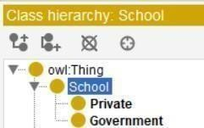

**Step 2: Add Class Hierarchy Descriptions**

* For Administration- Equivalent To🡺 Maintenance, SubClass Of🡺 Administrative.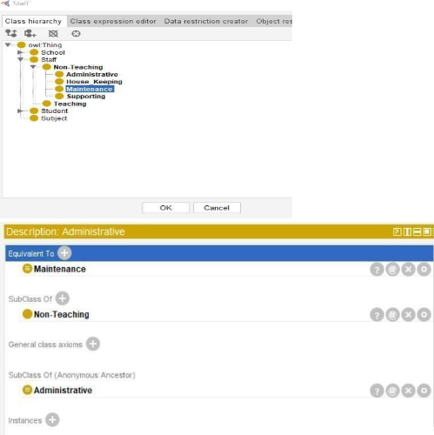

**Step 3: Start Reasoner.**

* Click on “**HermiT 1.4.3.456**”. Now Select “**Start Reasoner**” in Reasoner Tab.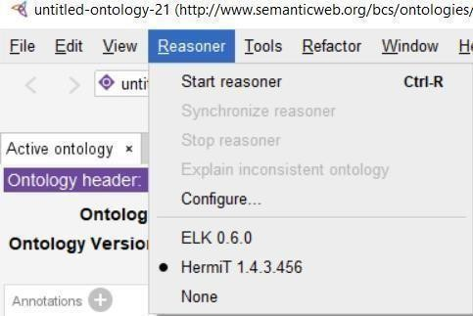

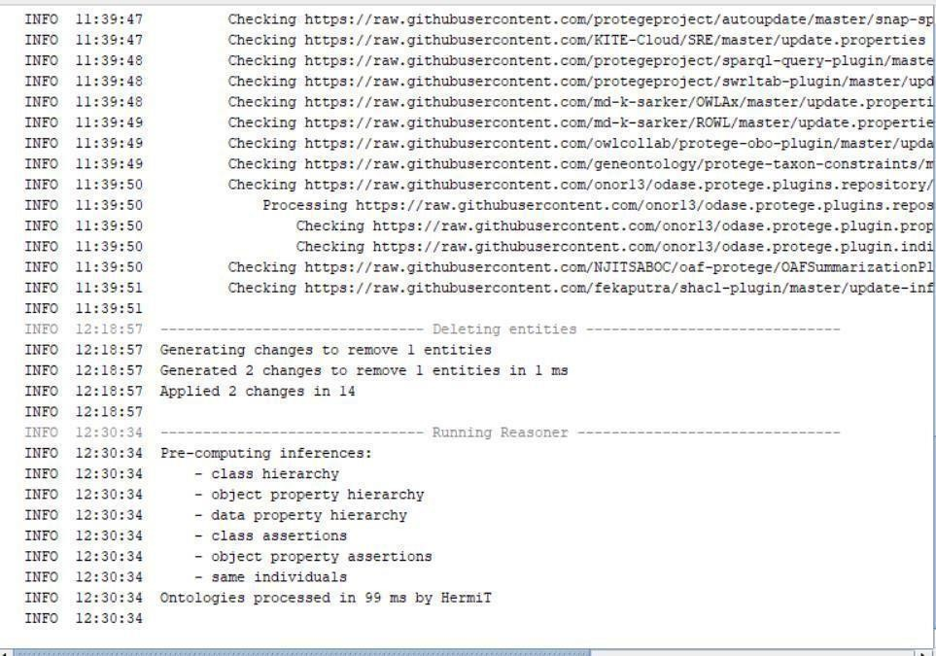

**Step 4: Click on window tab → Select Object Property.**

* Click on Add sub property → Add sub property- admits, employs, learns, teaches.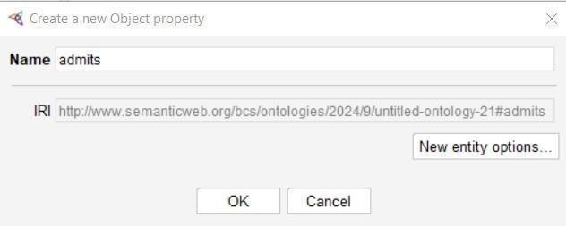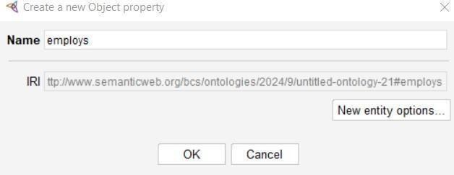

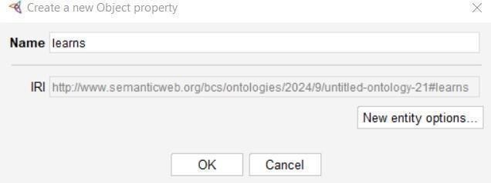

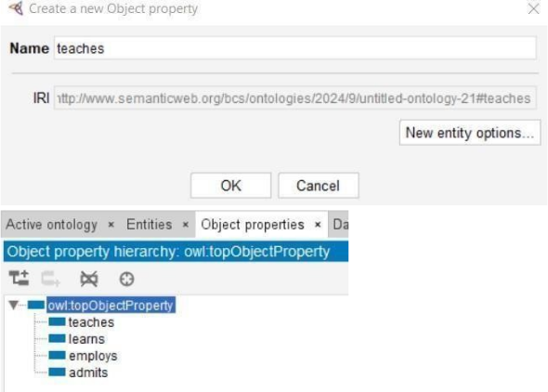

**Step 5: Add sub property Descriptions.**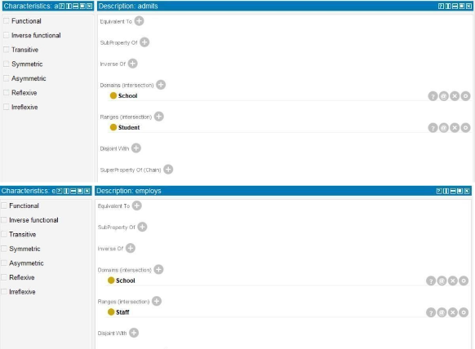

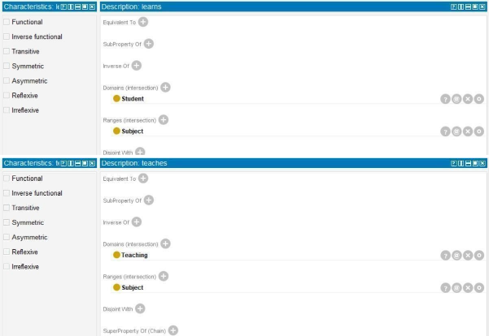

**Step 6: Click on window tab → Select Data Property.**

* Click on Add data property → Add data property- staffID, studentID, JoinedON, teach.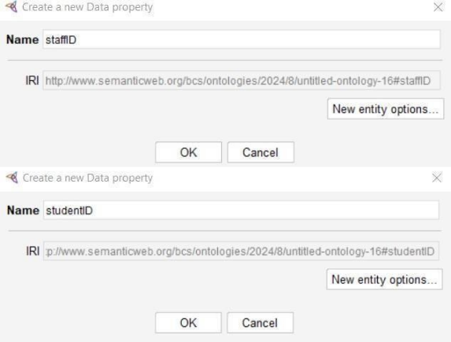

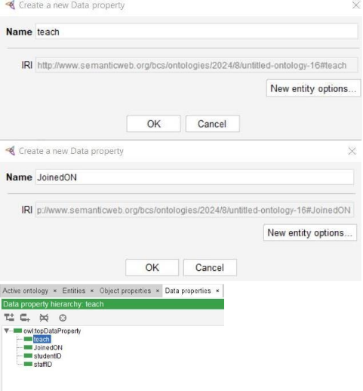

**Step 7: Add Description for Data Property.**

* Description: JoinedON

Domains🡺 Student, Ranges🡺 xsd:dateTime.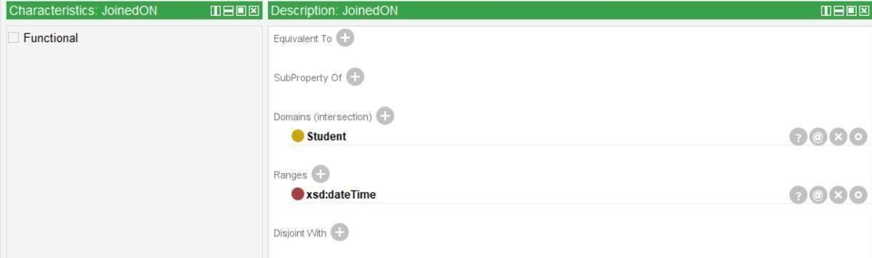

* Description: studentID

Domains🡺 Student, Ranges🡺 xsd:string.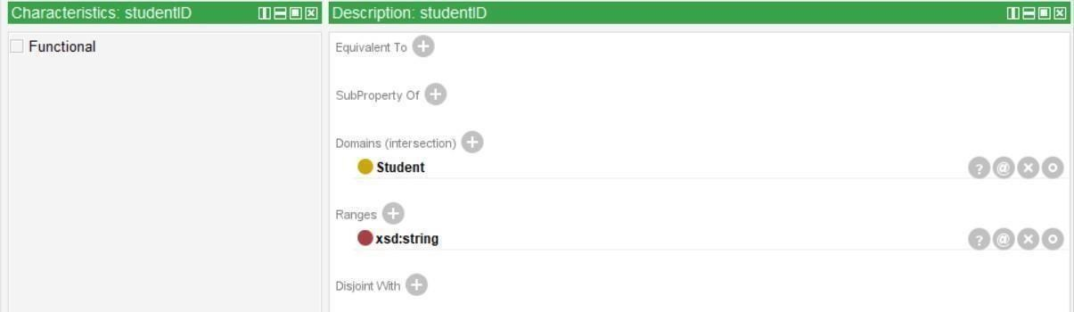

* Description: staffID

Domains🡺 Staff, Ranges🡺 xsd:string.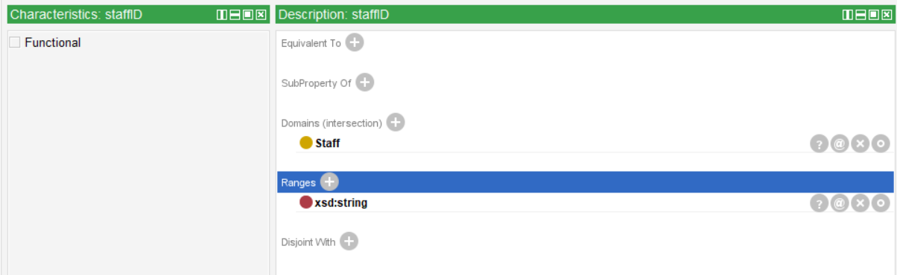

* Description: teach

Domains🡺 Teaching, Ranges🡺 xsd:string.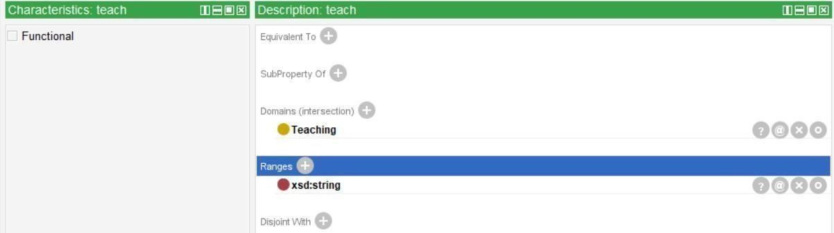

**Step 8: Again, Start Reasoner.**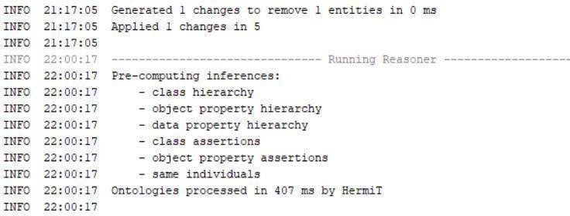

**Step 9: Click on window tab → Select Individual by class.**

* Click on student and click on .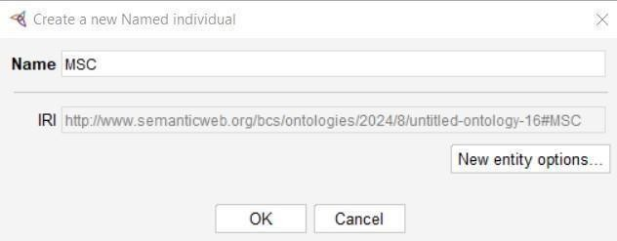

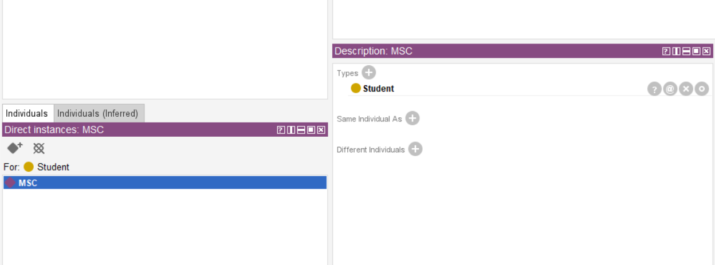

**Output of OWLViz:**

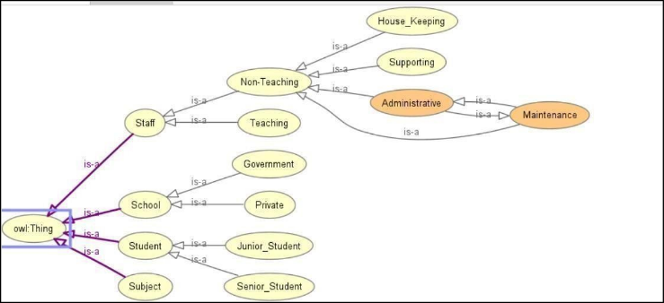

# Practical 24

**Create an Ontology for University**

**STEP 1: Download and Install Protégé and Graphviz.**

Open Protégé 🡺Click on file 🡺 Select Preferences 🡺 Add the path in OWLViz.

**STEP 2: Create a Class Hierarchy.**

Select Entities 🡺 Now Click on Classes by adding subclass.

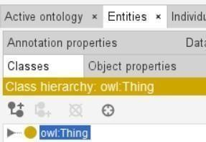

* Select owl:Thing and Click on SubClass to create the new class.

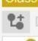

* Add the class as University in owl:Thing. Now create the subclass for university as Course, Departments, Job, Person, Subject.

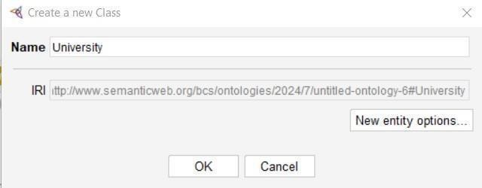

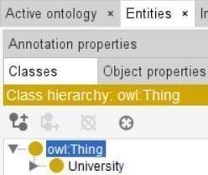

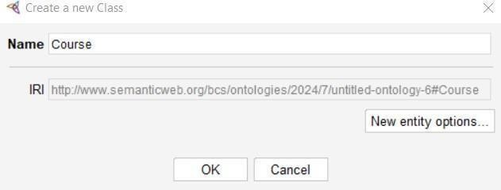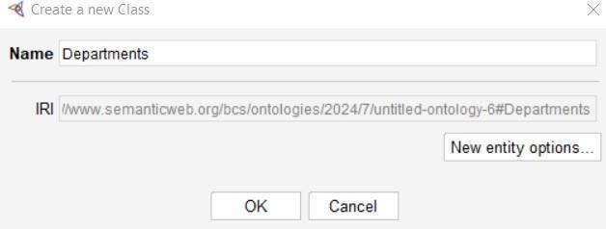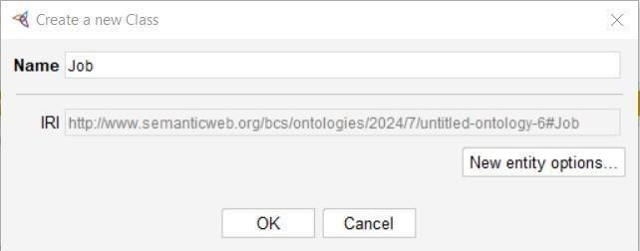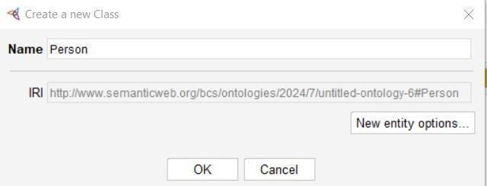

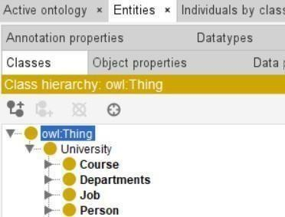

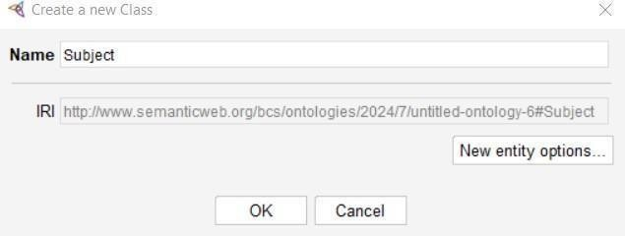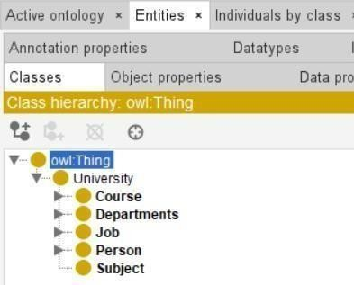

* Add sub class for Course- Accountability, BusinessManagement, CS, EEE, Mech.

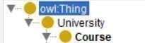

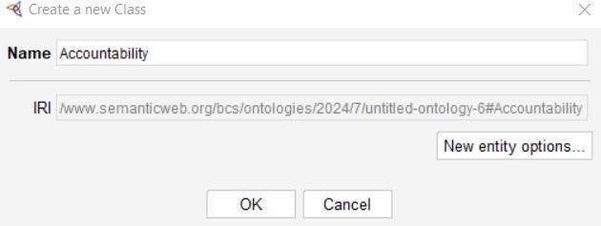

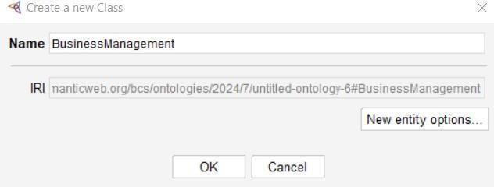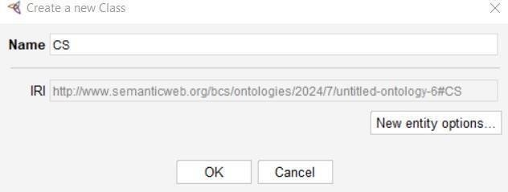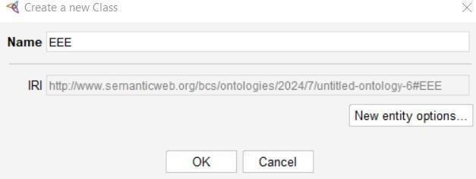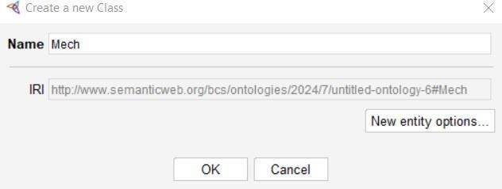

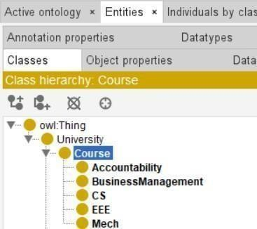

* Add subclass for Departments- Business, Engineering.

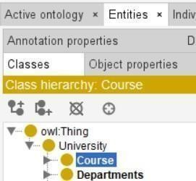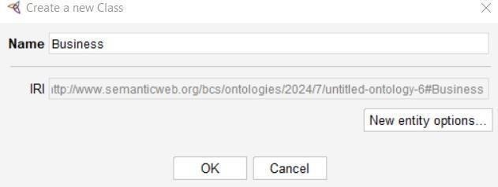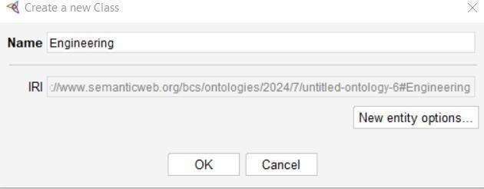

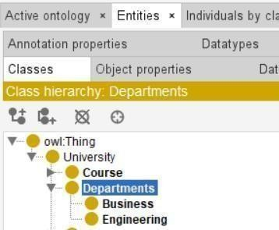

* Add subclass for Job- Administrative, Administrative_officer, AsstProf, Pro, Professor, RecruitmentOfficer.

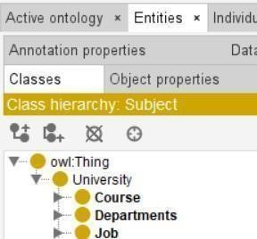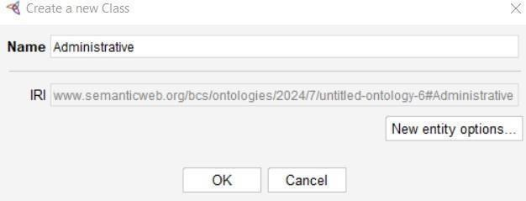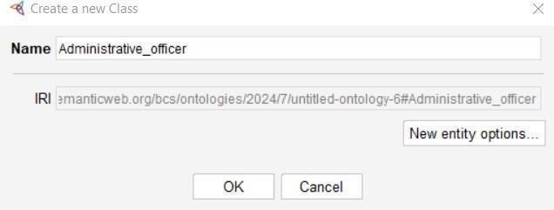

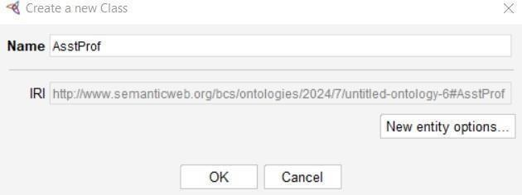

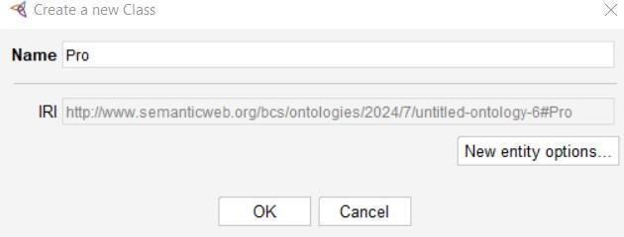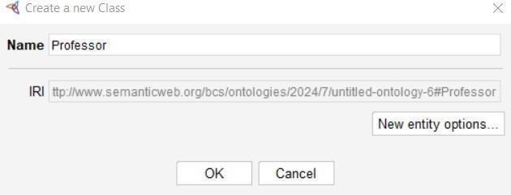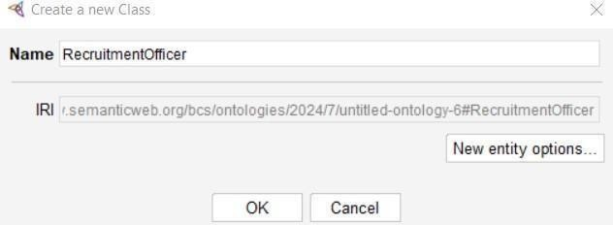

**STEP 3: Add Classes for Description**

* In windows tab 🡺 Select Classes

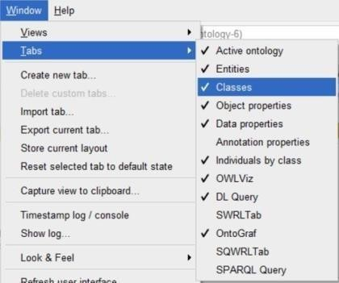

* + **For Administrative**
  + Add Equivalent To- Professor, Administrative_Officer.

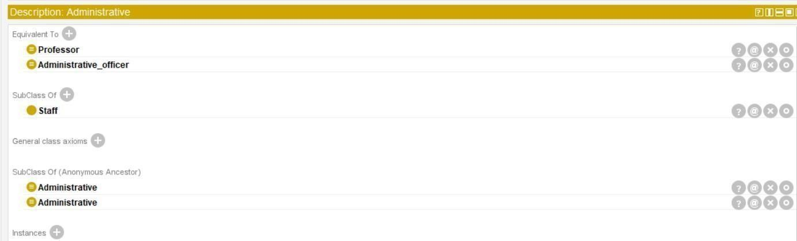

* + **For Administrative_officer**
  + Add Equivalent To- Administrative.

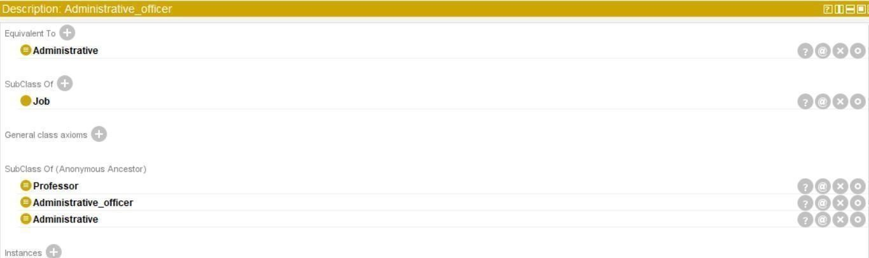

* + **For Professor**
  + Add Equivalent To- Administrative

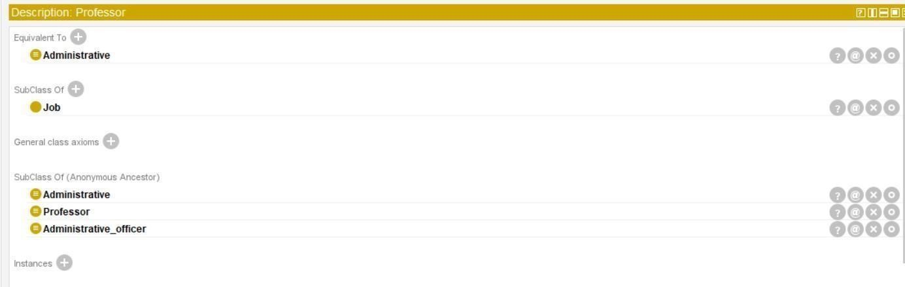

**STEP 4: Create a Class Hierarchy for Person in owl:Thing.**

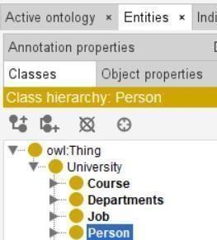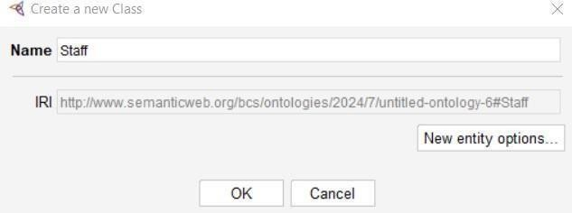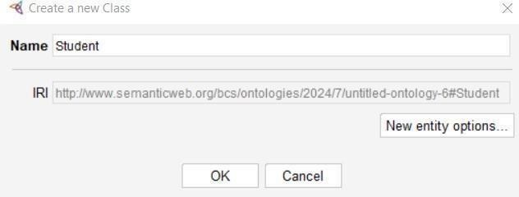

* In Staff add subclass- Academic, Administrative, Administrative_officer, Professor.

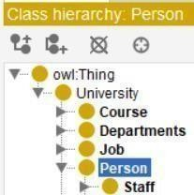

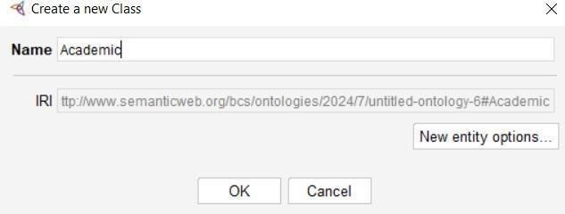



**STEP 5: Add Class Description**

For Administrative 🡺 Equivalent To- Professor, Administrative_officer.

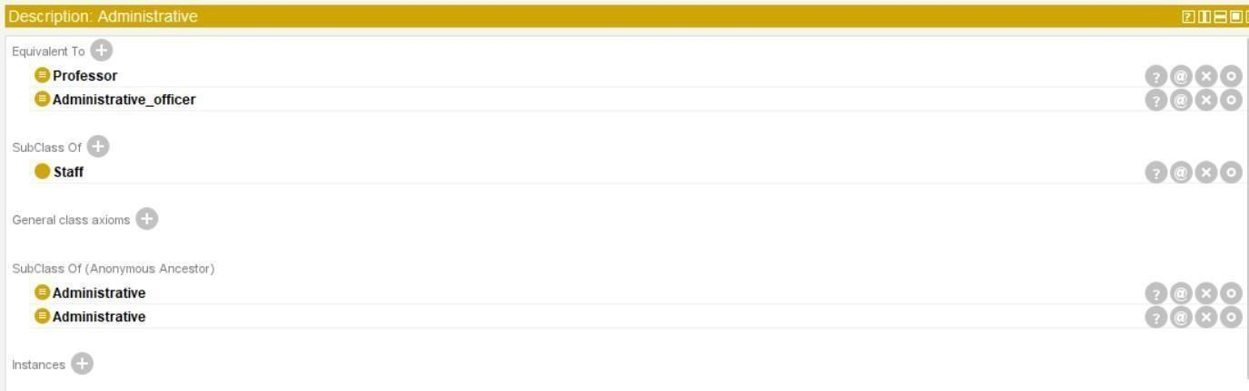

**For Administrative_officer and Professor** 🡺 Equivalent To- Administrative.

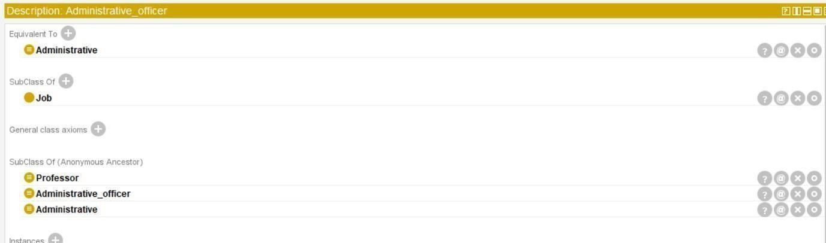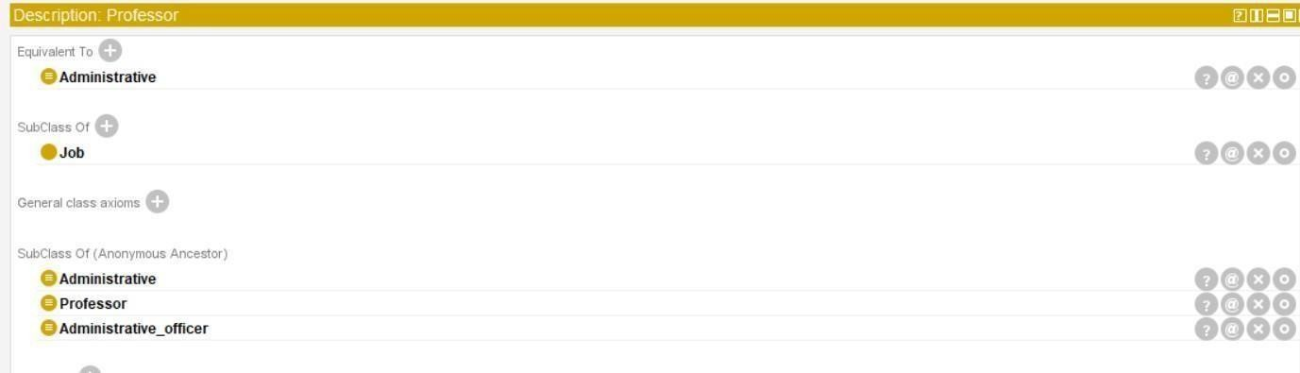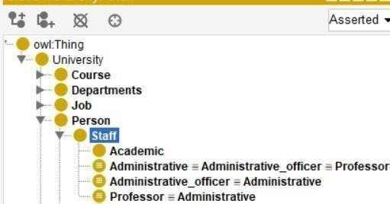

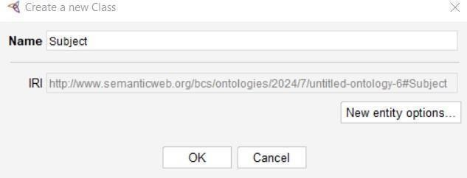

* Create a class hierarchy for student 🡺 PG Student, PHD Student, UG Student.

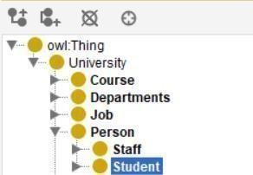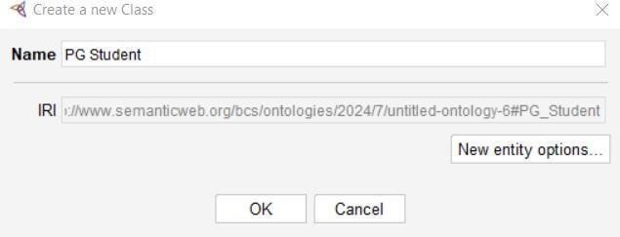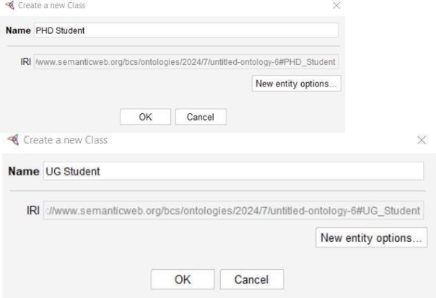

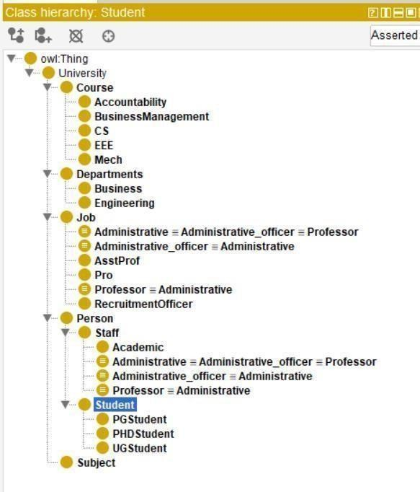

**Output of OWLViz:**

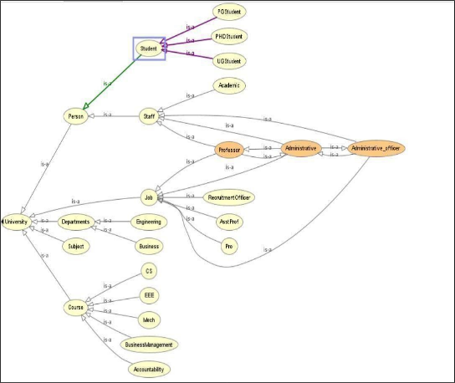

# Practical 25 Create a Pizza Ontology

**STEP 1: Create a Class Hierarchy.**

Select Entities 🡺 Now Click on Classes by adding subclass.



* Select owl:Thing and Click on SubClass to create the new class.
* Add the class as Pizza and PizzaBase in owl:Thing.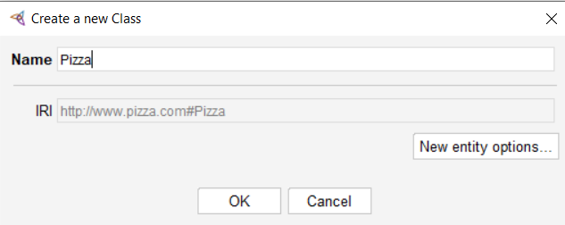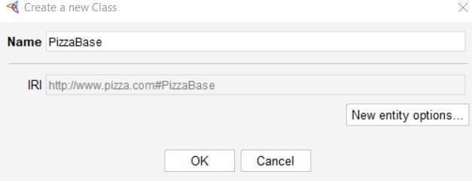
* Add the subclass for PizzaBase- DeepPanBase, RhinAndCrispyBase.

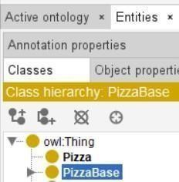

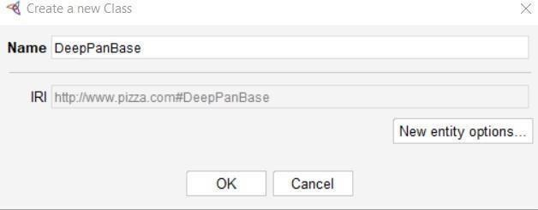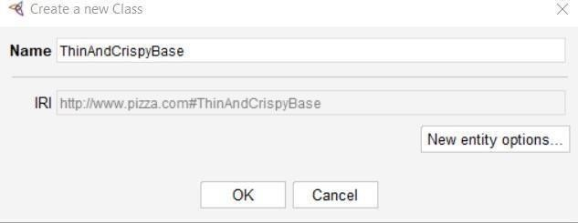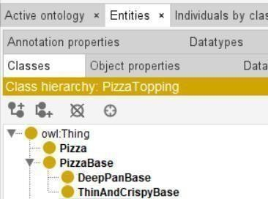

* Add a subclass in owl:Thing as PizzaTopping.

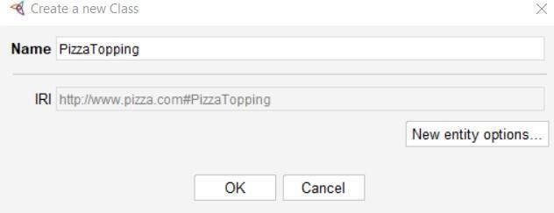

* Add a subclass for PizzaTopping 🡺 CheeseTopping.

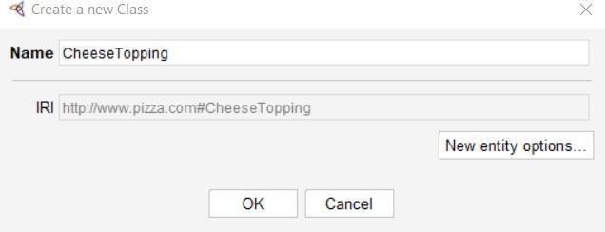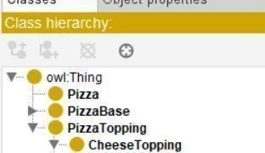

* Add subclass for CheeseTopping 🡺 ParmezanTopping, MozzarellaTopping.

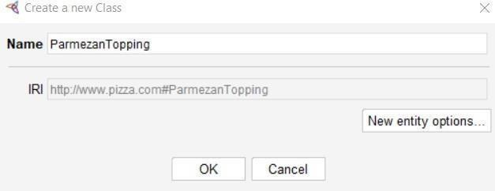

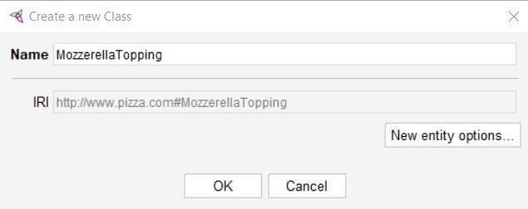

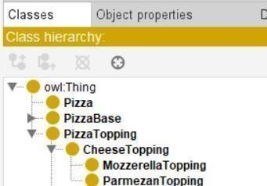

**STEP 2: Add a Class Description in Classes for Pizza** 🡺 **Disjoint With- PizzaBase, PizzaTopping.**

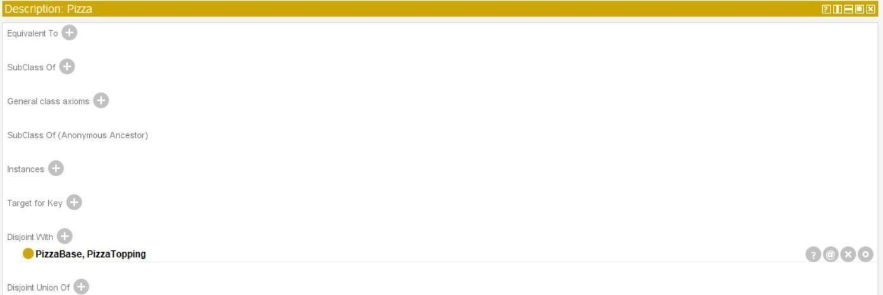

**Step 3: Create a subclass in PizzaTopping as MeatTopping.**

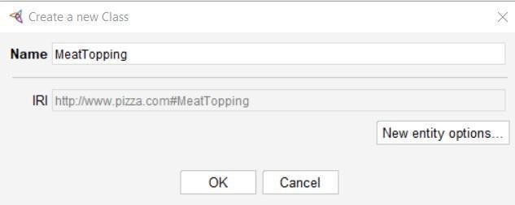

* Add a subclass for MeatTopping as HamTopping, PepperoniTopping, SalamiTopping,SpicyBeefTopping.

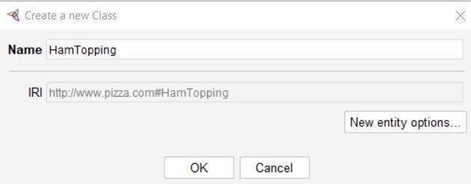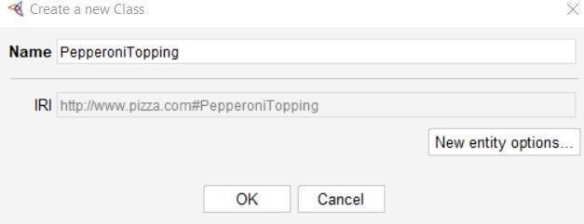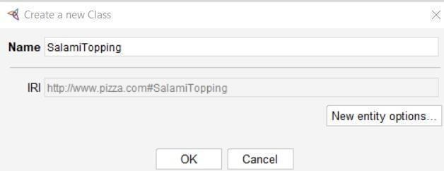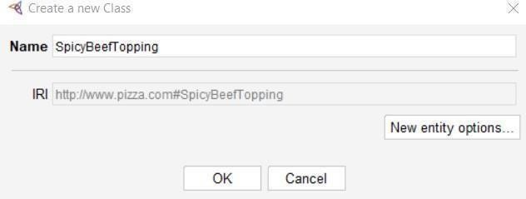

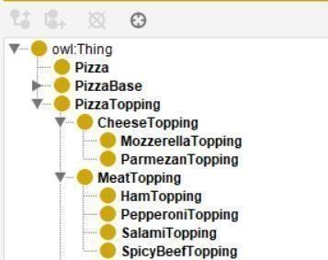

**STEP 4: Add a class description for MeatTopping classes** 🡺**SubClass Of- PizzaTopping**.

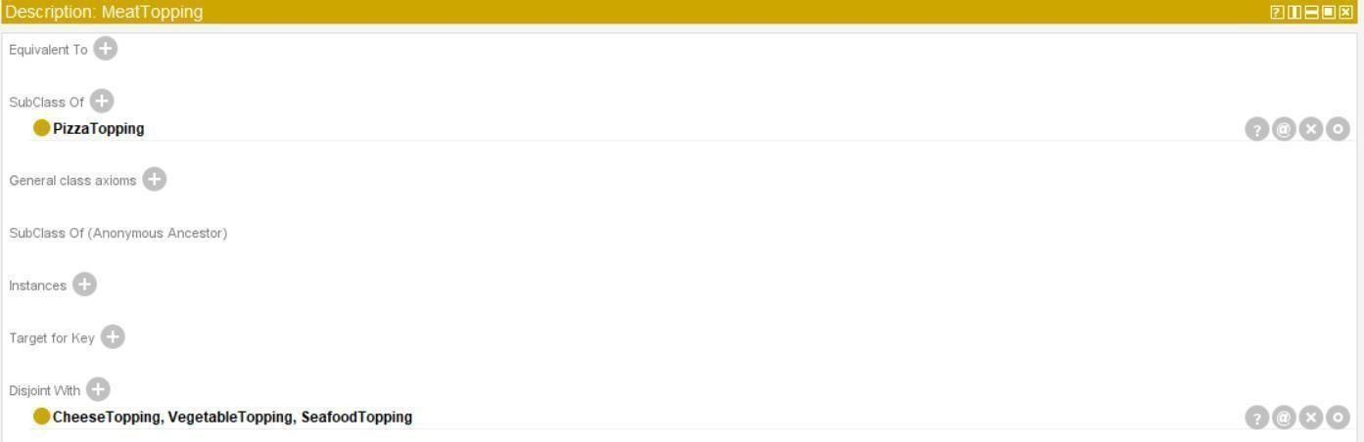

**STEP 5: Add a subclass in PizzaTopping as SeaFoodTopping.**

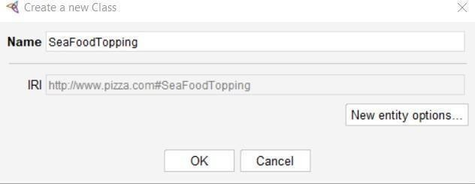

**STEP 6: Add a subclass for SeaFoodTopping as TunaTopping, PrawnTopping, AnchovyTopping.**

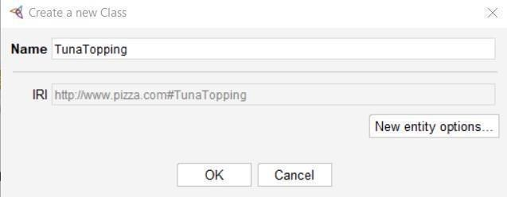

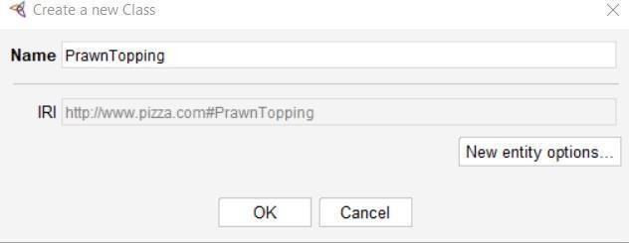

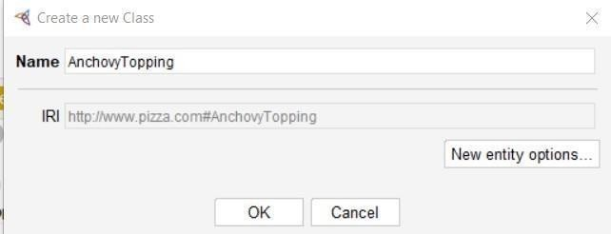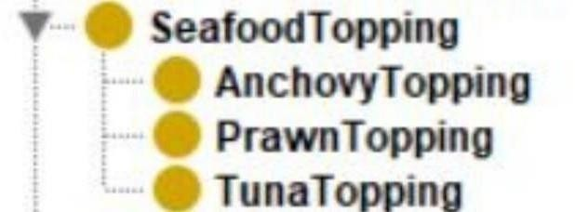

**STEP 7: Add a subclass in Vegetabletopping.**

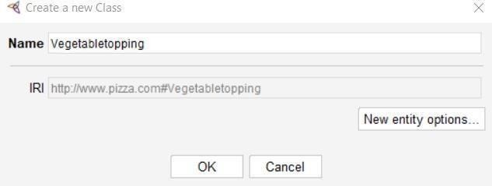

* Add a subclass for Vegetabletopping as Oniontopping, Olivetopping, Mushroom topping, Caper Topping.

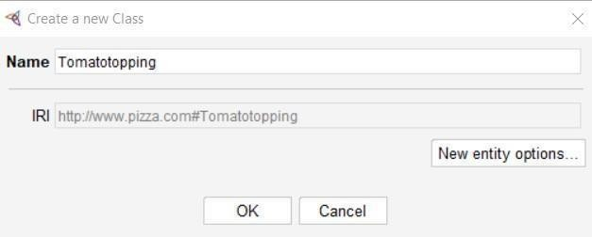

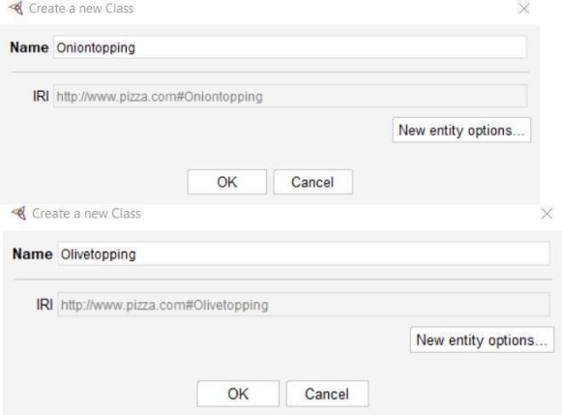

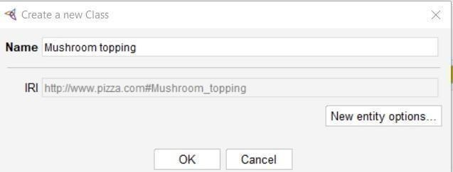

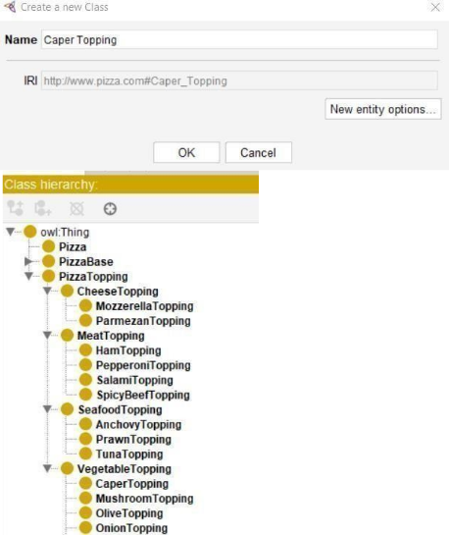

**STEP 8: Add a subclass in PizzaTopping as Pepper Topping.**

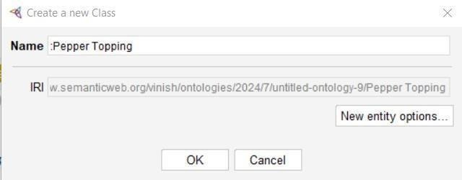

* Add a subclass in PepperTopping as Green Pepper Topping, RedPepper Topping, JalapenoPepper Topping.

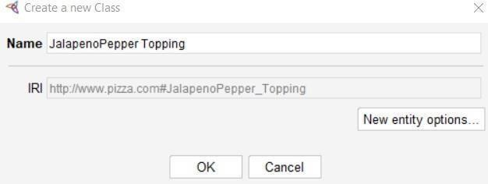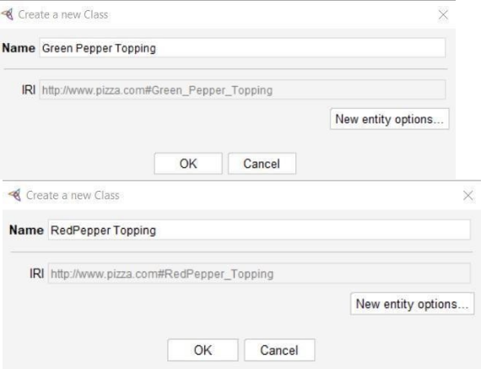

**STEP 9: Add a subclass in PizzaTopping as TomatoTopping.**

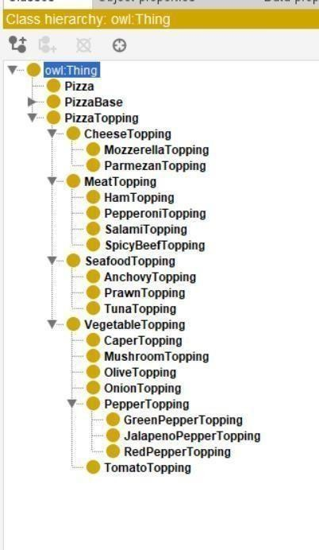

**STEP 10: Add a class description in classes**

* For MeatTopping 🡺 In SubClass Of- PizzaTopping 🡺 In Disjoint With- CheeseTopping, Vegetabletopping, SeaFoodTopping.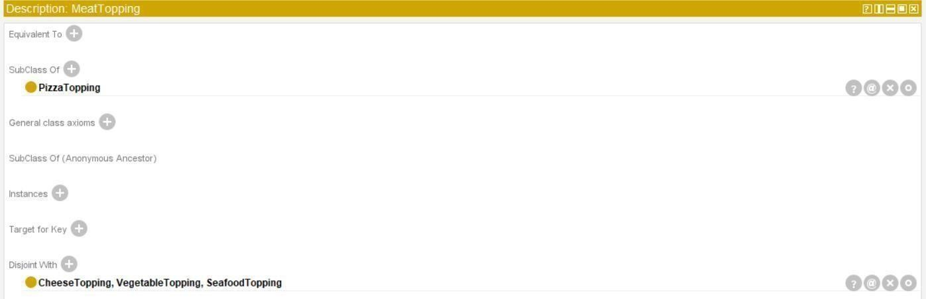
* For SeaFoodTopping 🡺 In SubClass Of- PizzaTopping 🡺 In Disjoint With- CheeseTopping, VegetableTopping, MeatTopping.

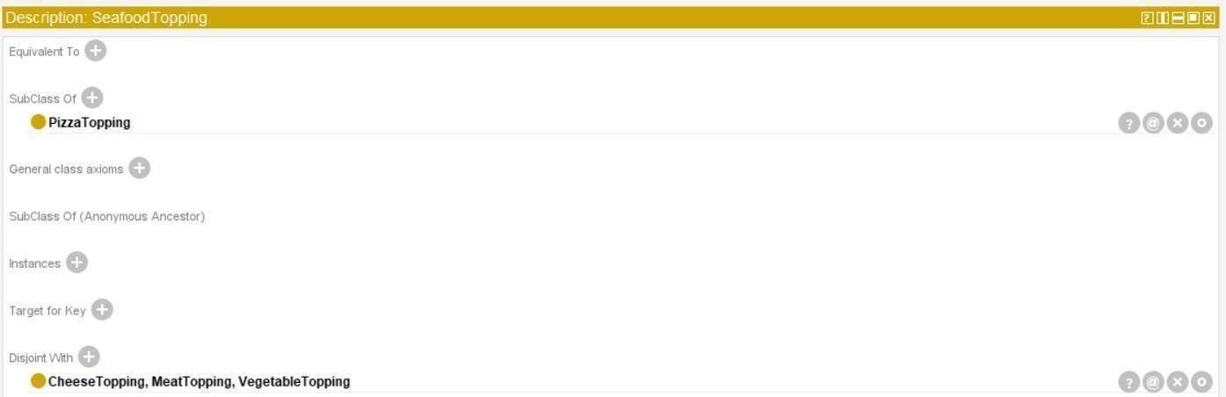

* For VegetableTopping 🡺 In SubClass Of- PizzaTopping 🡺 In Disjoint With- CheeseTopping, MeatTopping, SeaFoodTopping.

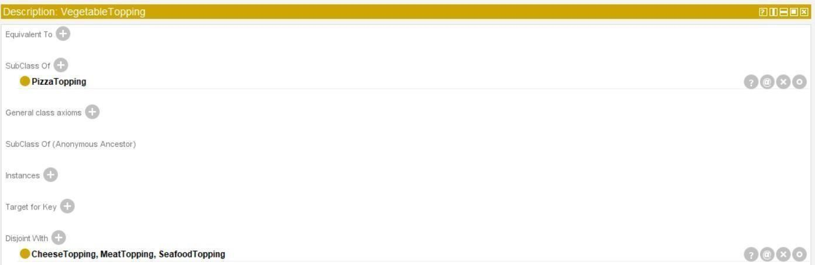

* For PepperTopping 🡺In SubClass Of- VegetableTopping 🡺 In Disjoint With- OnionTopping, CaperTopping, TomatoTopping, Olive Topping, MushroomTopping.

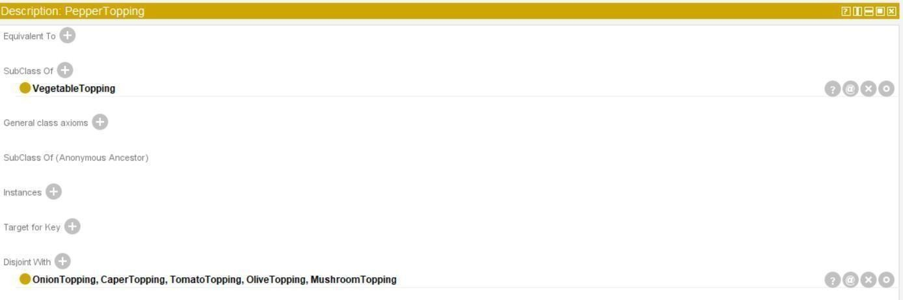

**STEP 11: Click on window tab** 🡺 **Select Object Property.**

Click on Add sub property 🡺 Add sub property- hasingredient and isingredient.

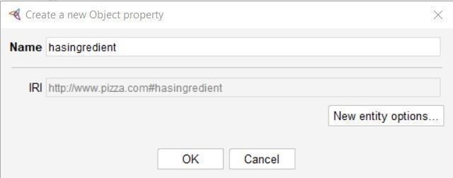

* Add sub property for has ingredient- hasBase, has Topping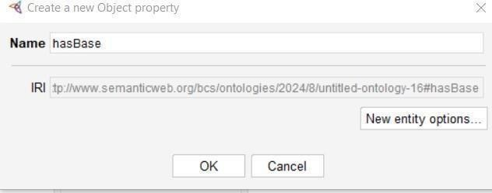

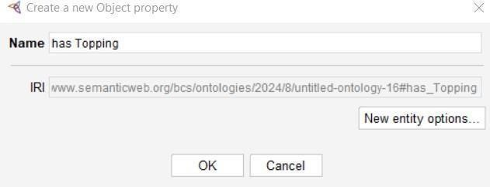

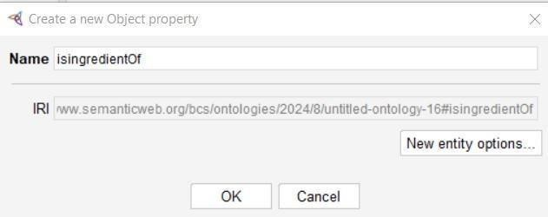

* Add sub property in isingredientOf- isBaseOf, isToppingOf.

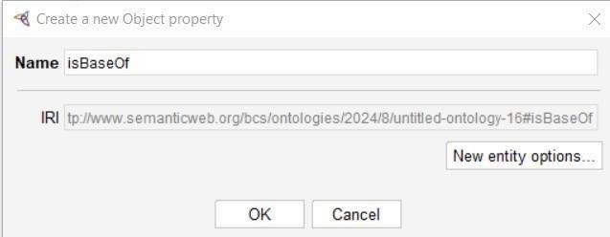

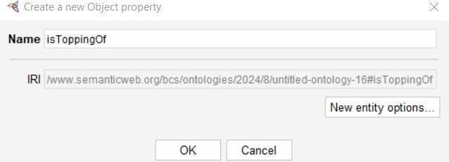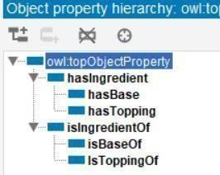

**STEP 12: In sub property description** 🡺 **Add SubProperty- hasingredient** 🡺 **Add Inverse Of- isBaseOf.**

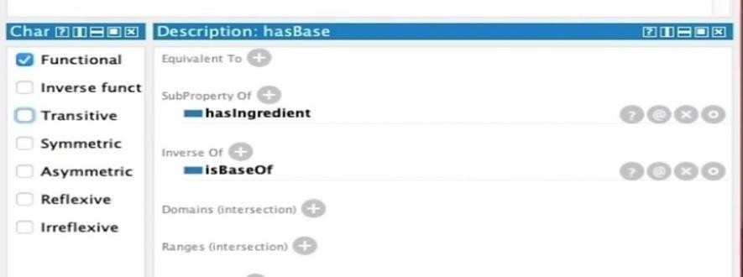

**STEP 13: Add a SubProperty description for isToppingOf.**

* Add SubProperty- isingredientOf 🡺 InverseOf- hasTopping 🡺Domain- Pizza 🡺 Ranges –

PizzaTopping.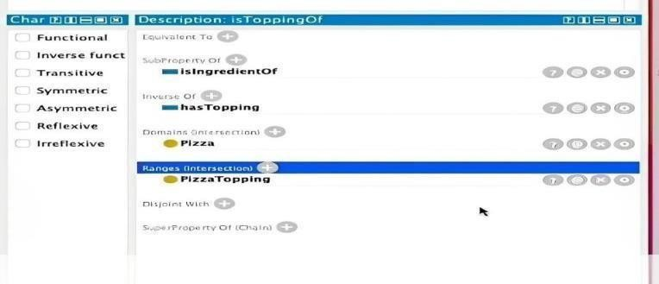

**Output for OWLViz:**

